“파라과이여, 다시 태어나라” (Paraguay must be born again) (요3:7)
Esperanza del Paraguay (“파라과이의 희망”)

Paraguay Mission 3rd Five Year Plan
"If a grain of wheat falls to the ground and does not die, there is one thing, and
if it dies, it will bear much fruit" (John 12:24)
The 5 goals of the 3rd 5-year plan
Worshipers, Disciples, Intercessors, Volunteers, Evangelists

Dear Officers and Supporters of JSBMF

Hallelujah!
Greetings to the JSBMF families in the love of our Lord Jesus Christ.
We want to apologize first for not delivering the missions report earlier due to summer vacation starting this past December.
The U.S. and Korea must have spent the winter season enduring the severe cold, but Paraguay had a hot summer unlike other summers. These days, the weather has softened up a bit and has become stable.
During the hot summer, we held <Summer Academy>, <1st and 2nd Youth Camps>, and <Summer Bible School Evangelism Rally>. Through the prayers of many churches and saints for the Paraguay mission field, we were able to deliver lost souls and finish with grace. Praise God!!! Thank you.
This year marks the end of the second five-year plan and the beginning of the third five-year plan.
Also, personally, it is my 40 years of ministries (30 years in the United States, 10 years of missionary work), and also our 40th anniversary of marriage which also holds a lot of meaning.
But in a bigger sense, my heart is overflowing with the hand of the Holy Spirit who will harvest many souls in the 10th year of missionary work.
★In the 2nd Five-Year Plan (2018-2023), the focus is on selecting and nurturing workers, making them warriors of Christ, and laying the foundation for guiding other children through them as they grow up. The pandemic period caused by Corona 19 and the deception of local architects lengthened and delayed the time, but the church building was dedicated in October 2021, and training to foster youth leaders was conducted in the church to create two groups to train children as leaders. Training will be conducted for the end of August 2023, and then the second five-year plan will come to an end. At that time, we will start Sunday school with the youth leaders we raised, and hold summer camps and summer Bible school evangelism meetings.
★In the 3rd Five-Year Plan (2023 ~ 2028), we will make it like the 50 <Christ's Solders> who were with Prophet Elisha and the 300 <Warriors of Christ> who were with Gideon.
When 350 regular soldiers are created, we will plant churches in 10 places through <Christ's soldiers>.
For this work, from December 2022, we are making a group filled with the Holy Spirit through retreats and prayer meetings.
“Jesus came and said to them, “All authority in heaven and on earth has been given to me; therefore go and make disciples of all nations, baptizing them in the name of the Father and of the Son and of the Holy Spirit, teaching them to obey everything I have commanded you. I will be with you always, even to the end of the world”
(Matthew 28:18-20).
We will fulfill the great mission of mission given by the Great Commission.
★ Children's Sunday School starts in 2023
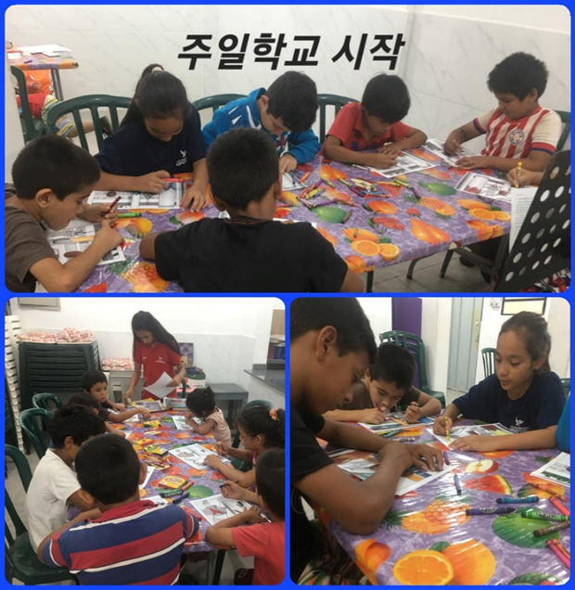
Last year, as I was going to give a pay to the person that taught Sunday School, I was going to ask for them to take a leadership role to be in charge of Sunday School, but that Sunday I found out that they came late and left early before Sunday School was over.
Through this, I thought it would be too hasty to ask this person to be in charge of Sunday School, and through the prompting of the Holy Spirit, I asked them to step down. So instead, on Saturdays, I prepared our youth even if they were little lacking to take care of the youth group on Sundays.
We divide 30 children into 3 classes and guide them well. Hallelujah!!!

★ 1st, 2nd Retreat and Summer Academy
This summer has started to get hot early and has been going on for a long time.
During summer vacation, which started in December, we called the children to church and started a summer academy.
There was no teacher to teach, so I had to divide the teaching into A Group and B Group. Even so, the children followed along well and the Youth took care of the smaller ones and spent time teaching them together. I had a fun and memorable time.
The little ones went on a picnic to the zoo.
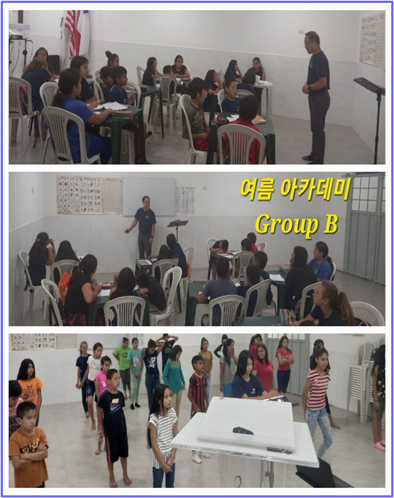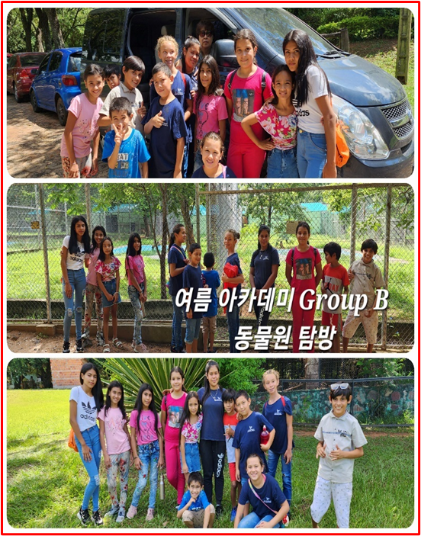
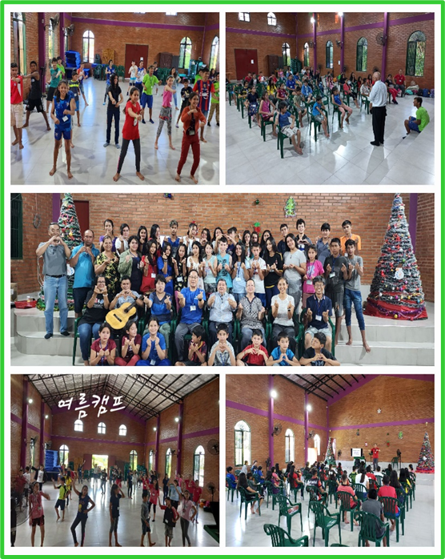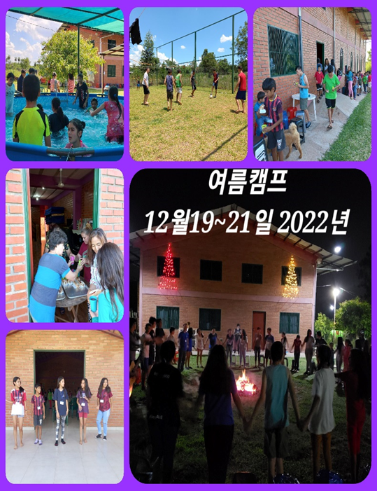

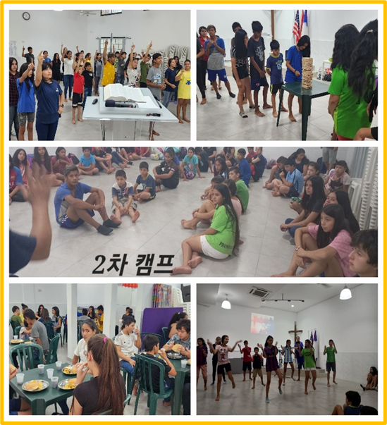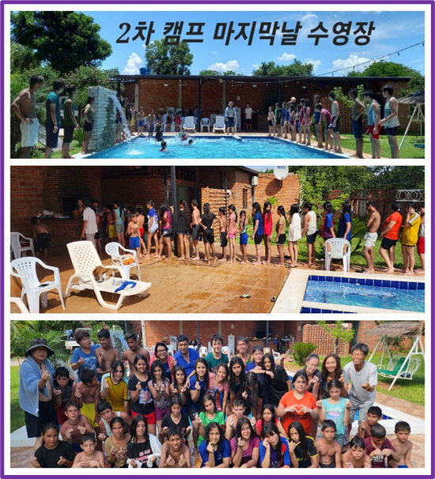

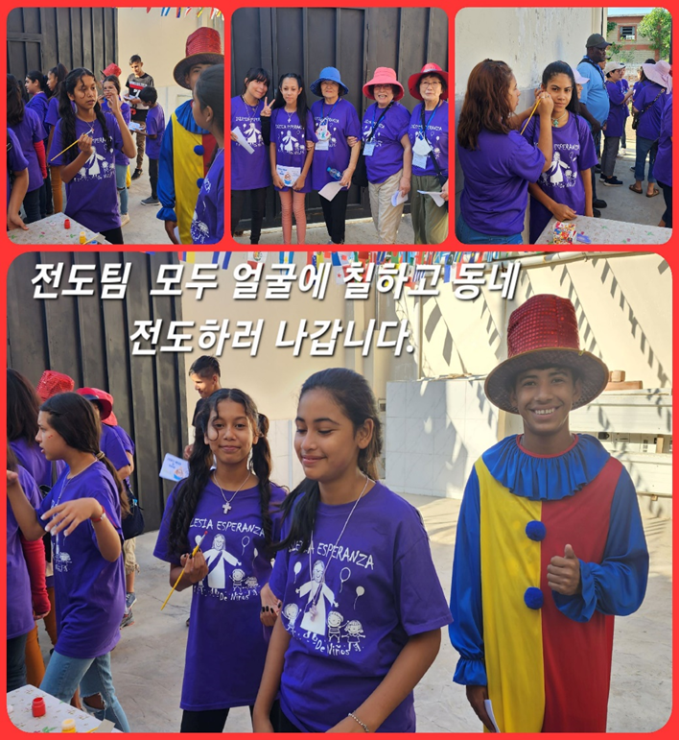
★ VBS Evangelism meeting (Thursday ~ Sunday)
The first summer bible school evangelism meeting was completed by the grace of God. Special thanks to Pastor Hyungcheol Choi, his wife, and 9 deacons of Full Gospel Hinesville Church who came from a long distance changing flights 3 times, prepared food and gifts with love, and worked together with the evangelism team.
For 4 days, more than 400 children listened to the Word and exercised at church.
We had a lot of fun eating food that we tried for the first time.
It was a time of challenge and memories for the children.
We pray that the great work of harvesting souls will be accomplished through evangelism meetings every year.!!!

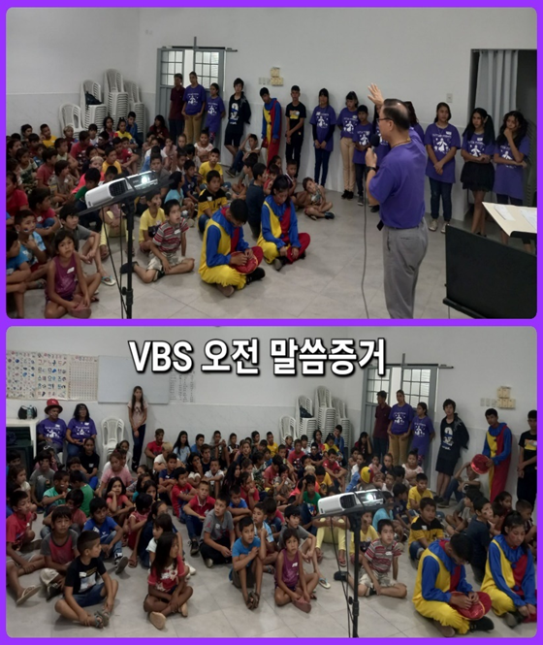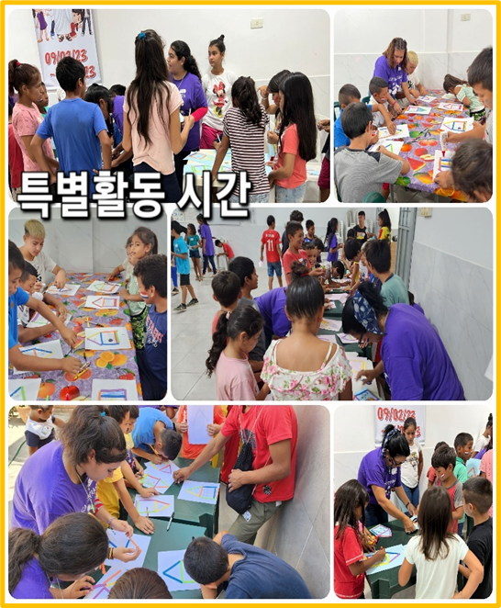
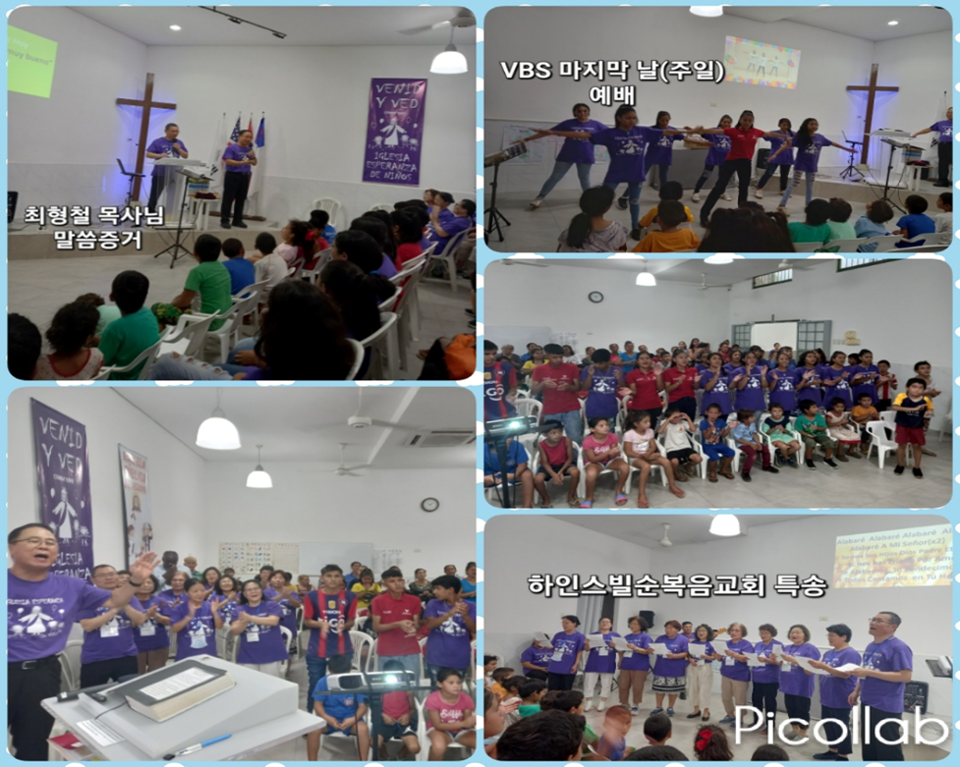
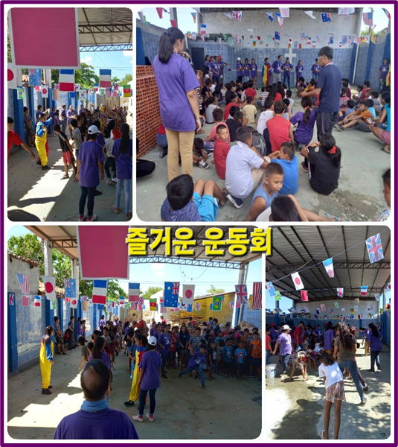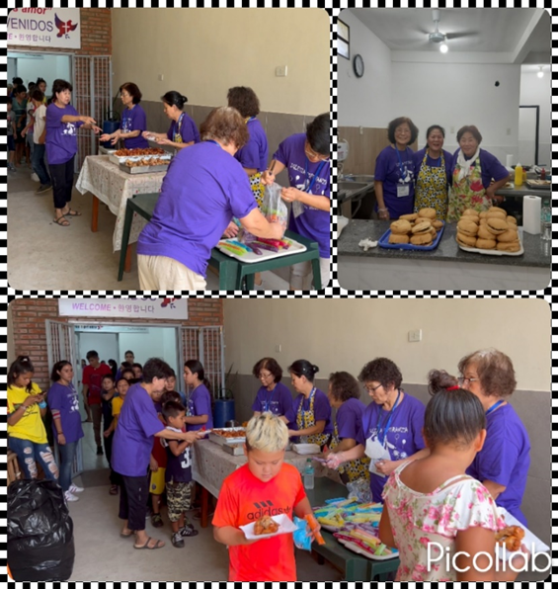
맛 있는 식사 시간, WOW!

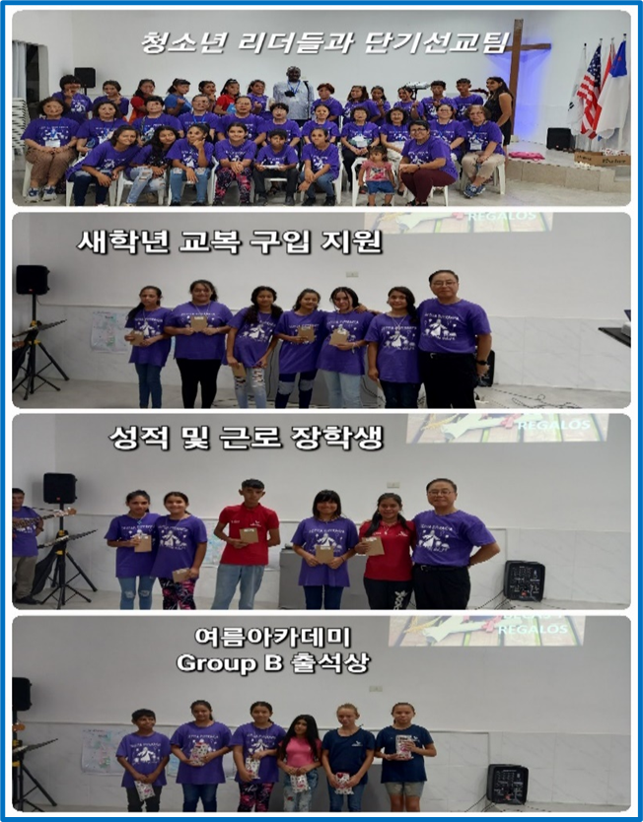
On the last day of the Summer Bible School evangelism meeting (Sunday service), we shared scholarships (2 students) to newly selected youths this year and work scholarships (4 students) to diligent youths with difficult family circumstances. There are children who continue to receive it after last year, but there are also teenagers who are newly receiving it. In particular, Hinesville Full Gospel Church supported the purchase of school uniforms for the new school year, so it was shared with 6 teenagers.
Even though they live in slums, the children who attend church and live in faith realize that God is a great person as they see how they are changing compared to other children.
God is Great!!!
Dios es Bueno!!!

In last year's <Winter Academy> (July), not only my wife and I, but also Pastor Paul Park and His wife, Elder Kenneth Park and his wife (Pastor Julie Park) visited us from the United States and carried out the ministry together. They helped us a lot and worked together. While experiencing God's goodness, I am grateful that missionary work is not done alone, but with the help of the Korean Assembly Council and pastors. I am especially grateful to the Overseas Mission Committee.
We think the 3rd 5-year period will be an important turning point for the Paraguay mission.
It is not only the work of making <Soul Harvest> and <Christ's Warrior>, but also the time when youth leaders are graduating from high school, and it is a time when each of them must open their own future, so it is a period for the church to think about what and how to lead.
When the school reopens, we run English classes on weekdays and Korean classes on Saturdays.
In the third five-year plan, vocational training schools, bakeries, and nurseries are planned. All of these plans are possible only with the approval and guidance of the Holy Spirit. We move forward believing that the Holy Spirit, who has guided us well until now, will guide us for the harvest of souls. “Behold, I am with you always, even to the end of the age.” Amen. Thank you for the prayers and love from the members of JSBMF. Shalom.
Your missionaries in Paraguay
Ok Jin & David Nam

★<Prayer Topics for the 3rd Five-Year Plan for Paraguay Mission (September 2023 to August 2028)>
1. For <Hope Academy> and After School – securing church workers and teachers
2. For building education centers, bakeries, and opening kindergartens
3. Evangelization of the entire village of <Bañado Sur>, the slum where the church is located.
4. 350 <Christ's Warriors> Goal
5. May the history of soul salvation be enriched through <Church of Hope>.
6. For the continuation of the fullness of the Spirit.
“Paraguay, Born Again!”
My Lord, my God. Please receive us and lead us! Amen.
<Contact Information>
● US Mailing Address (미국 연락처) : All Nations
1516 Lakeway Drive • Little Elm, TX 75068
● Bank of America (Pay to the Order : All Nations Church of Dallas)
Routing #: 111000025 Account #: 488028516745
● e-mail : davidnam1128@gmail.com
● Paraguay Address (파라과이 연락처)
Taquari y entre 38 y 39 projectada • Asuncion, Paraguay +595 994-796900(cell phone)
● 한국: NAM DAVID HAK(국민은행) 054901-04-203605

