**Prayer Letter of May & June 2023**

1191/150 The Parkland- Bangna, Bangna Trad Rd, Bangna, Bangkok, Thailand 10260 [woody.kim@om.org](mailto:woody.kim@om.org)

Dear Prayer Partners,

Shalom! I greetings to you all! In Thailand, the weather is unpredictable due to climate change. The price of everything in the market has gone up. Thais are struggling as wages are staying the same. Although the prediction of business is not doing well after the election, Thai Christians and churches are seeking God and remained in His faithfulness.

In May and June, OM Europe, Oceania, and North America allocated funds towards OM East Asia projects. Praise the Lord for His provision, OM EAA (11 countries) has raised 1 million out the total 2023 project funds $3 million. Those who receive project funding are required to write reports for financial transparency and ministry report, so it is a big challenge for Woody when they don’t meet these requirements. We hope that the least-reached people group project in the Mekong region (5 countries) will be well supported, and we are excited to set up in Vietnam. **Pray that the Lord gives wisdom to Woody to prepare the EAA Project report and set up projected finances for Vietnam.**

It's been a long time since Woody has been able to preach a sermon (6/11) at Abundant Love Family church. It was surprising to see how the children of our disciples had grown up and the number of children had increased. For the last 23 years in the journey with the disciples, some of them have more grey hair than us. Time has gone fast and full of joyful old memories. We welcomed a new pastor and his wife with two children for the church**. Please pray for Pastor Frame, his wife Toei, and their two sons: Euro and Judah.**

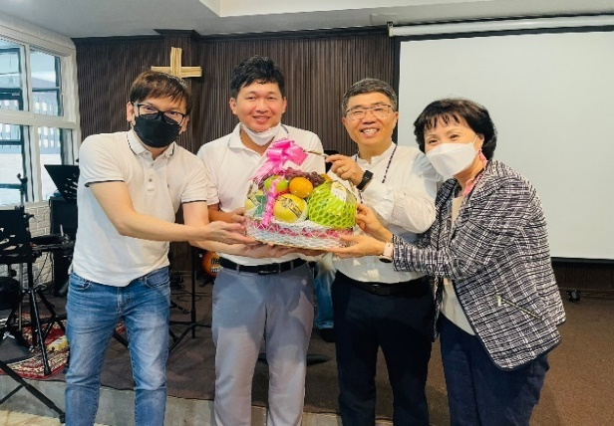From June to August, we are hosting a short-term mission team each month from Korea and US. Mostly, they come for few days like a vision trip. We hope that they explore Thailand see what God is doing and as they worship with Thai believers, fellowship with them and pray for Thailand. **Pray for the joy of ministry while they are in Thailand.**

Abundant Love Family Church after service Pastor Frame (2nd from the left) 10K step at a local park

In early July, Doulos Hope Ship will make its first ministry stop in Penang, Malaysia. Woody will join the ship and share the Mekong project financial development with local churches and potential donors on the 7/22-25. Esther is doing well in her coaching academy training while she coaches 3 people and leads 5 prayer -through-the-scripture meetings. It is a joy to see the fruit of the ministry as her trainees start to lead another prayer groups.

**Pray for Doulos Hope ministry in Penang & Esther’s ministry and the healing of her knee pain.**

After Woody's disc surgery, your prayers have answered for his quick recovery. Esther and Woody continue to walk 10k steps every day. We see your prayers making a big difference not only for our family, but also in the ministry. We would like to close our letter with Phil 1;3-5 **“I thank my God in all my remembrance of you, always in every prayer of mine for you all making my prayer with joy, because of your partnership in the gospel from the first day until now.”** God bless,

**Woody, Esther, Irene, Nathan, Diane Kim**

Financial Support: For Online giving -please click on this link- <https://give.omusa.org/om/donate?sc=&fund-id=8000>To: OM, Memo: Woody & Esther Kim, Operation Mobilization, P.O. Box 444 Tyrone, GA 30290 1-770-631-0432