“파라과이여, 다시 태어나라” (Paraguay must be born again) (요3:7)
Esperanza del Paraguay (“파라과이의 희망”)

Paraguay Mission 3rd Five Year Plan
"If a grain of wheat falls to the ground and does not die, there is one thing, and
if it dies, it will bear much fruit" (John 12:24)
The 5 goals of the 3rd 5-year plan
Worshipers, Disciples, Intercessors, Volunteers, Evangelists

Dear Officers and Supporters of JSBMF

Hallelujah!
Greetings to the JSBMF families in the love of our Lord Jesus Christ.
It has been 10 years now since we have been carrying out missionary work here in Paraguay.
Thinking back to the first time I was dispatched as a missionary to Paraguay, I planned my future.
While ministering in the United States for 30 years, I meditated on <What should I prepare for when I go as a missionary?> and prepared the following mentally.
1. Let's have a proper mission plan and strategy.
2. Let's secure finances for missions and manage them transparently.
3. Let's achieve the patience of missionaries and supporters together.
4. Let's fulfill our mission only under the guidance of the Holy Spirit.
I have been meditating on the above 4 missionary directions for 10 years.
I have various regrets while handling 40 years of ministry as a pastor and missionary in the United States, but looking back, I have nothing to confess except <God's grace>.
As the apostle Paul confessed, “I do not count my life of any value to myself, if only I may finish my course and the mission I received from the Lord Jesus, to testify to the gospel of God’s grace” (Acts 20:24).
We will run forward again for the missionary mission given to us.
We believe that you will continue to cooperate with the prayers and love that have been with you for the evangelization of Paraguay.
As already mentioned in the mission message sent last June, the 3rd Five-Year Plan starting in September is a very important period for us.
As young children grow up and become teenagers, there are many emotional ups and downs, they pay attention to their appearance, they have a sense of comparison with houses in good places, and they think dating is obvious.
A few days ago, a high school freshman left home in the afternoon and didn't come back overnight, only to return home the next afternoon. Parents reported her missing to the police and worried about her, but when she returned home, she was alone without a word. Even when mom and dad ask, they just say, “nothing happened” and don’t say anything else.
When I went to the atrium and asked her, she replied, “I went to my uncle’s grave in the afternoon and got lost.” The family situation is difficult, so I just think that I can conflict alone in my heart.
There are so many things our church has to handle for these children.

Also, the 3rd Five-Year Plan is very important because after the construction of the education center, 50 youths will live together in the academy building, and the Holy Spirit will be with them to raise 300 people as leaders. It is also a period of rededication to see if children can continue to grow into <Christ's warriors>.

★ Installation on the project wall

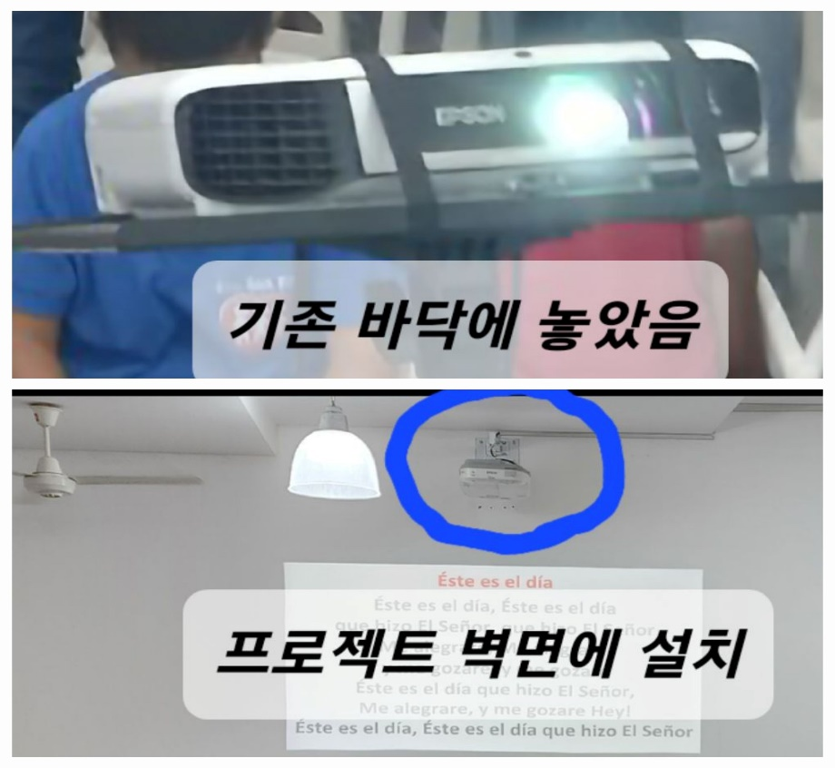

I put the existing project on the floor, but Pastor Hyung-Cheol Choi, who visited in February, brought it to Paraguay as a gift from Elder Young-Il Yoon of the Korean Church of Pittsburgh (Pastor Young-Sun Cho), and installed it on the wall with Pastor Joo-Young Kim, who visited in June. . It's so nice to be able to use the floor space widely.
What I realized with one project is that missions cannot be accomplished without the cooperation of many people, not alone. Elder Young-il Yoon, Pastor Hyung-cheol Choi, Pastor Joo-young Kim, thank you again.
★ Father's Day 2023
Paraguay, like the United States, also celebrates Father's Day on the third Sunday in June.
I was very moved by the children writing letters and bringing them back to read.
Children who say “Meeting the pastor is the best gift”, “I will live like the pastor” …
Reading the children's letters touched my heart. Rather, we get joy and feel happy because of my children. Praying to the Lord <May these children grow up as clean and innocent as they are now!>
In the evening, we invited children living with their mothers without fathers, bought whole chickens, and enjoyed fellowship with them. Hallelujah!!!

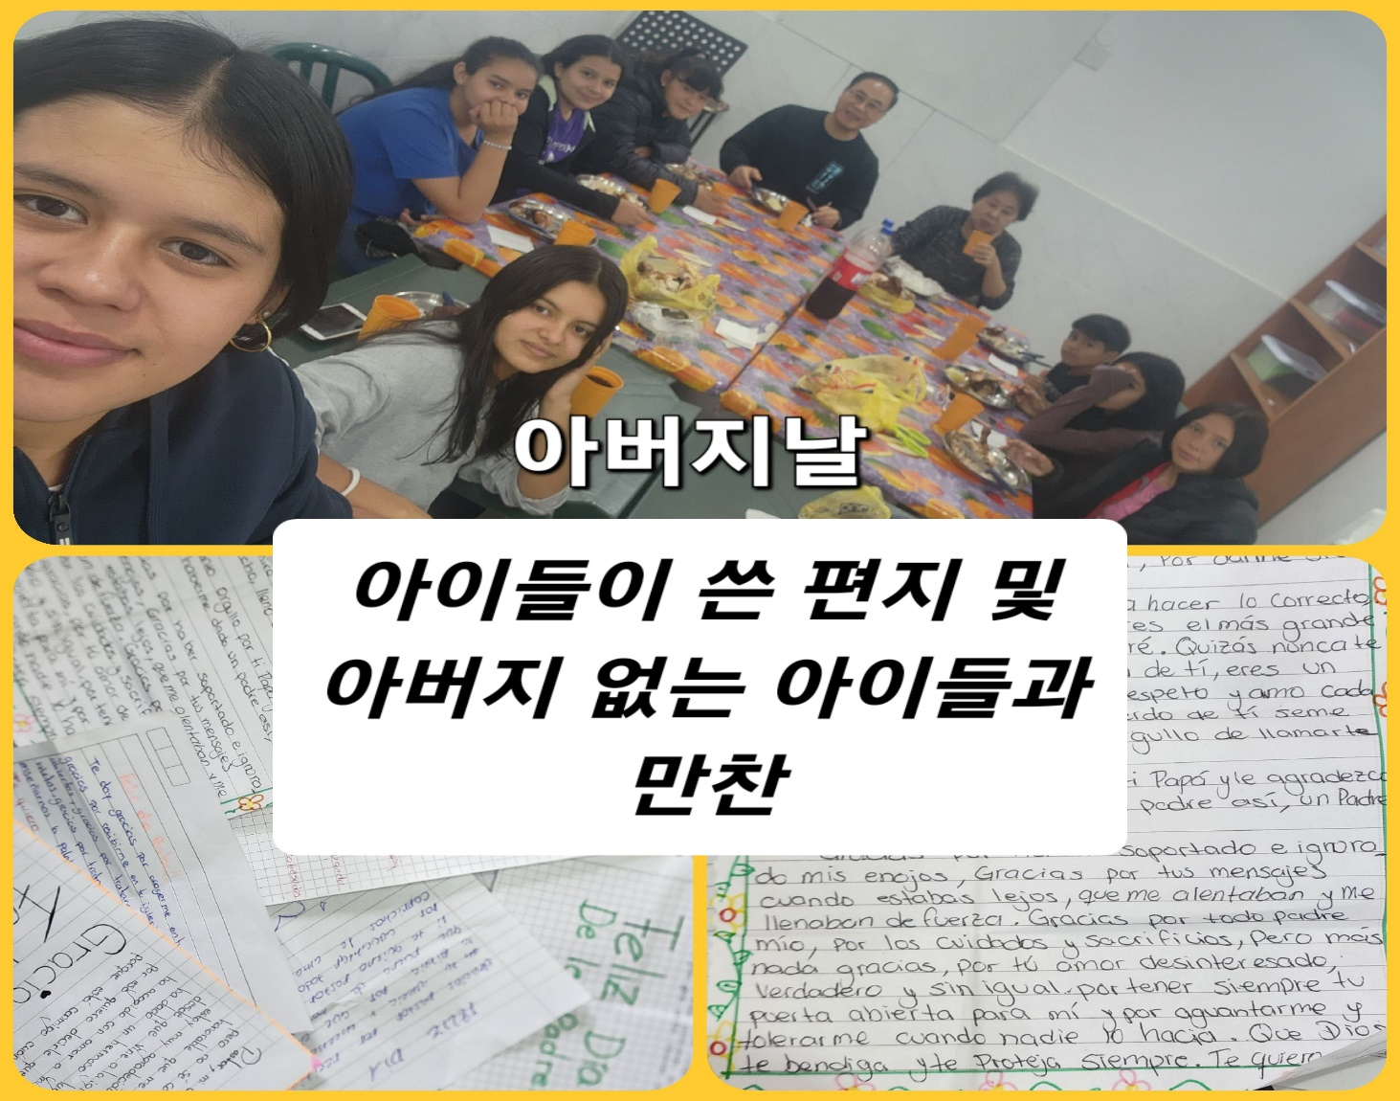

★ Teaching musical instruments to teenagers during winter vacation in 2023
Pastor Joo-Young Kim (153 Church), wife Hee-Ok Joo, and Deacon Sarah Seo visited, and Pastor Joo-Young Kim taught the children drums, guitar, and piano for a month. Among those who have visited so far, I had a good time with the children and learning musical instruments while staying the longest.
During this winter vacation, we did not hold a public <Winter Academy>, and decided to teach instruments to church leaders and children.
In order to set up 10 evangelism places within the next five years and send children to evangelism every Saturday, guitars and drums are crucial, so we decided in advance and had a very beneficial time.
Paraguay doesn't know music itself because they don't teach music in schools from elementary school to high school.
Also, most of the children sing hymns in one note because they do not know music. It was promoted to overcome the situation where I was good at dancing but not so good at singing, but Pastor Kim Joo-young and his wife worked so hard.
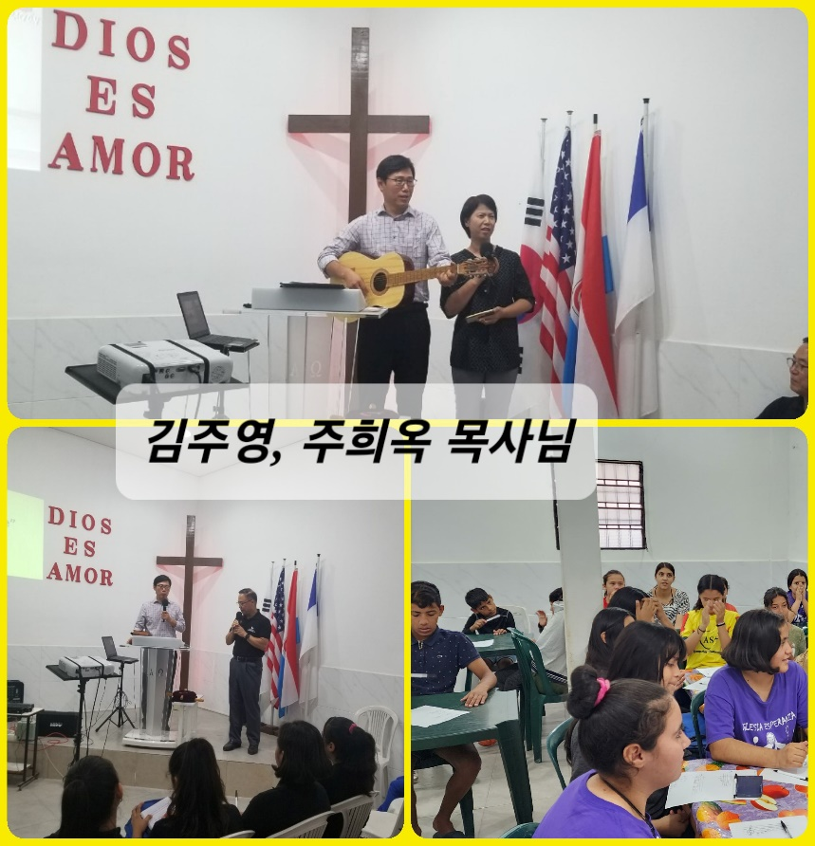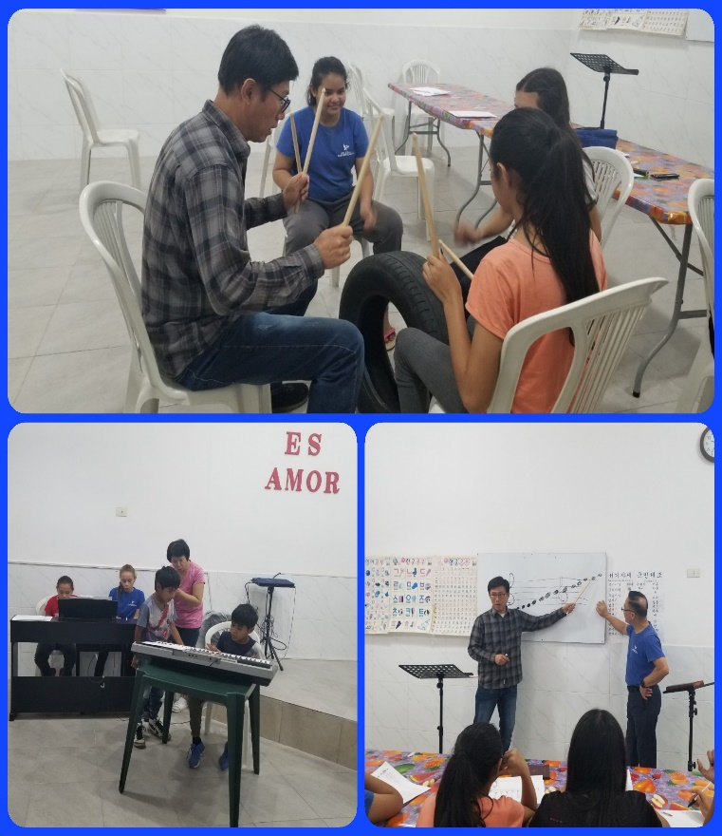
The piano requires more time, but I am so thrilled that I have taken the first steps to learn instruments.
A local pastor continues to teach guitar, and we are looking for a teacher to teach piano.
Also, I am learning the drums myself and learning with the children. Through this opportunity, I want to learn the drums, save lecture fees, and gain strength for evangelism.

In front of the grand proposition of <God's mission>, I bow my head in gratitude to the pastors and church members for enduring infinite sacrifice and working together with passionate devotion.
I believe that the fruits of the mission field are blossomed with full-fledged prayer and love.
“I planted, Apollos watered, but God caused the growth. So neither the one who plants nor the one who waters is anything, but God who gives the increase” (1 Corinthians 3:6,7).
Thank you for participating in the watering work at JSBMF. We hope that we can rejoice and rejoice together as we see the fruits produced through honest missions planting the gospel.
We pray that the glory of the Lord will be filled in the JSBMF all members, and families in the hot summer.
thank you. Shalom.

Your Missionaries in Paraguay
Ok Jin & David Nam

★<Prayer Topics for the 3rd Five-Year Plan for Paraguay Mission (September 2023 to August 2028)>
1. For <Hope Academy> and After School – securing church workers and teachers
2. For building education centers, bakeries, and opening kindergartens
3. Evangelization of the entire village of <Bañado Sur>, the slum where the church is located.
4. 350 <Christ's Warriors> Goal
5. May the history of soul salvation be enriched through <Church of Hope>.
6. For the continuation of the fullness of the Spirit.
“Paraguay, Born Again!”
My Lord, my God. Please receive us and lead us! Amen.

