“파라과이여, 다시 태어나라” (Paraguay must be born again) (요3:7)
Esperanza del Paraguay (“파라과이의 희망”)

Paraguay Mission 3rd Five Year Plan
"If a grain of wheat falls to the ground and does not die, there is one thing, and
if it dies, it will bear much fruit" (John 12:24)
The 5 goals of the 3rd 5-year plan
Worshipers, Disciples, Intercessors, Volunteers, Evangelists

Dear Officers and Supporters of JSBMF

Hallelujah!
Greetings to the JSBMF families in the love of our Lord Jesus Christ.
By now, the United States has entered the cool fall season, and the mountains and fields are covered in beautiful autumn leaves.
However, disasters occurring all over the world still pose a serious risk to people and animals.
The forest fires in Canada are not going away, the forest fires on the island of Maui in Hawaii, the earthquake in Morocco, Africa, and the floods in Libya are taking lives and causing the pain of having to leave one's beloved home.

We also faced great difficulties due to flooding in early September.
During the construction of the church, the ground was raised by 60cm, but due to heavy rain for two days, rainwater reached the main sanctuary of the church

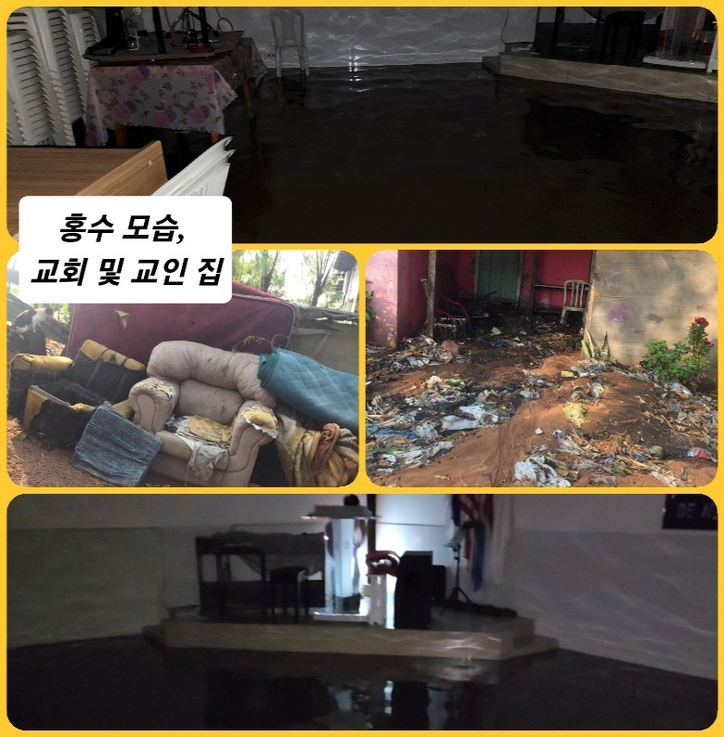
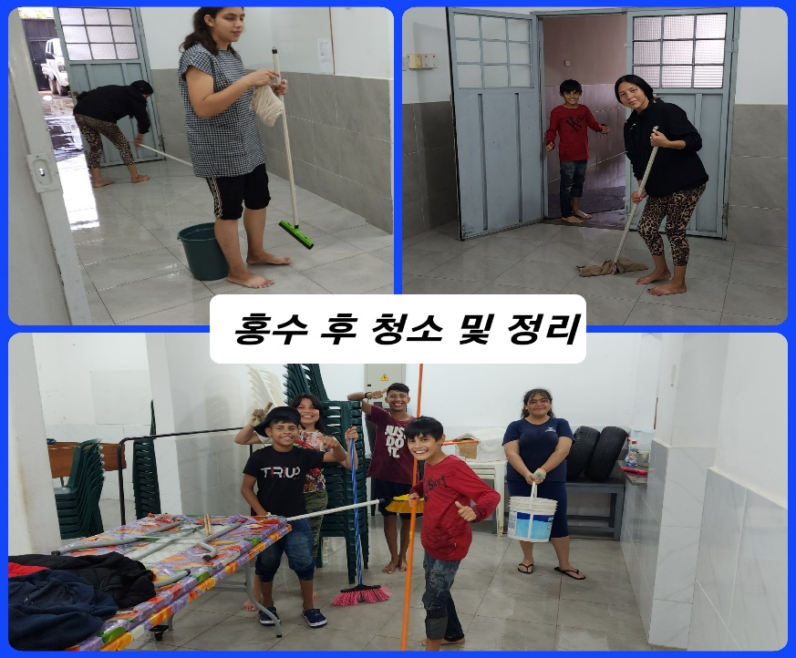
The area where the church is located is constantly flooding.
There was no flood damage for the past four years, so the construction was completed under God's guidance. In particular, a riverside road (4m to 5m high) was being built on the riverside adjacent to the church, so I thought it would be safe, but there was no way to avoid the sudden heavy rain.
As I feel helpless against climate change and cannot help but think that it is a disaster brought on by humans, I meditate on God's plan and providence.
While recalling the scenes of the end times recorded in the Bible, nevertheless, “the righteous will live by faith” (Habakkuk 2:4).
Holding on to the Word, we move forward as “become a faithful and wise servant, taking charge of the people in the household to our master and distributing food at the right time.”

Currently, in Paraguay, spring officially began on September 21st, but the country remains in mid-summer heat (40°-45°).
Last Sunday, we had a difficult service because even the air conditioner was in bad condition.
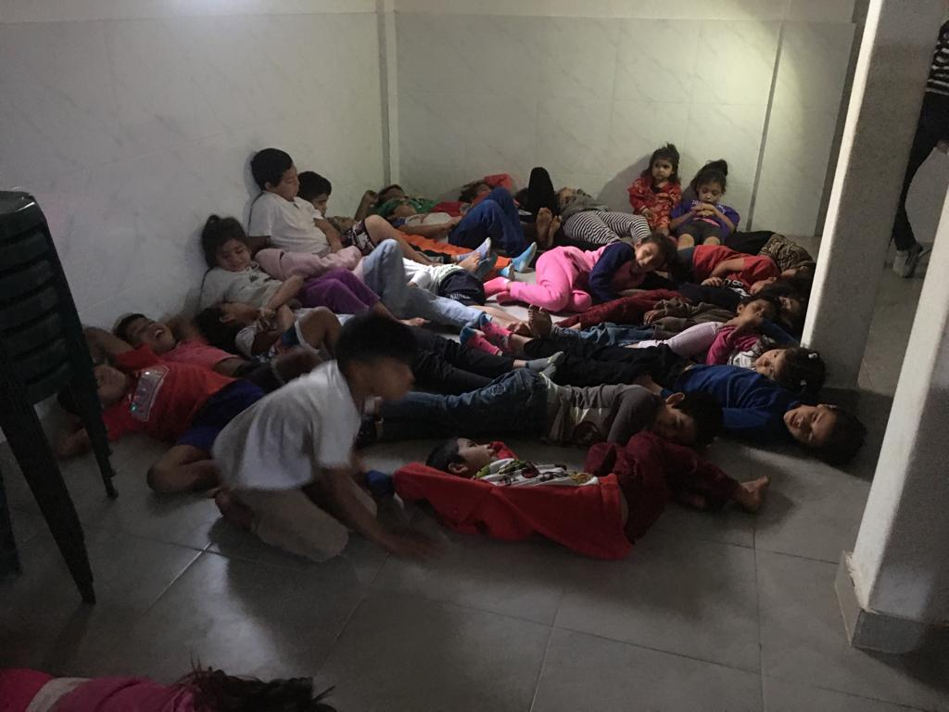
주일학교 아이들이 친교실 바닥에 누워서 더위를 식히고 있습니다.(사실은 이스라엘 백성들이 광야에서 쉬는 모습 재연 ㅎㅎㅎ)
After the flood, we were happy and excited to see children volunteering to come to church and clean the church, and we gave thanks to the Lord.
we realized that raising children is not a waste of time. There were times when it was difficult to live in the reality that children do not move without compensation and are always demanding compensation, but we are just thankful that they are turning into dedicated and loyal children through the work of the Holy Spirit. Hallelujah!!!

★Pastor Cho Young-son, Chairman of the Overseas Mission Committee, visited
As the Chairman of the Mission Committee of the Korean General Assembly, he personally visited the sites where missionaries were sent to re-establish the direction and policies of the General Assembly's missionary work. Starting from Honduras, He came to Paraguay and we were able to have many conversations.
In addition, missionary Lee Dong-cheol, who is working in Honduras, accompanied us, and in order to document the mission field in Paraguay, Deacon Hyun-joon Kim (World Vision video director, NC Evergreen Church; pastor Woong-cheol Kim) also visited and filmed the Paraguay ministry. .
At the General Assembly level, we thank you for your prayers and love for the missionaries sent overseas.
We would like to sincerely thank you for your love and love for visiting Paraguay in South America, which is far from the United States, and providing comfort and encouragement even though it is a difficult journey with flights departing and arriving late at night or early in the morning.

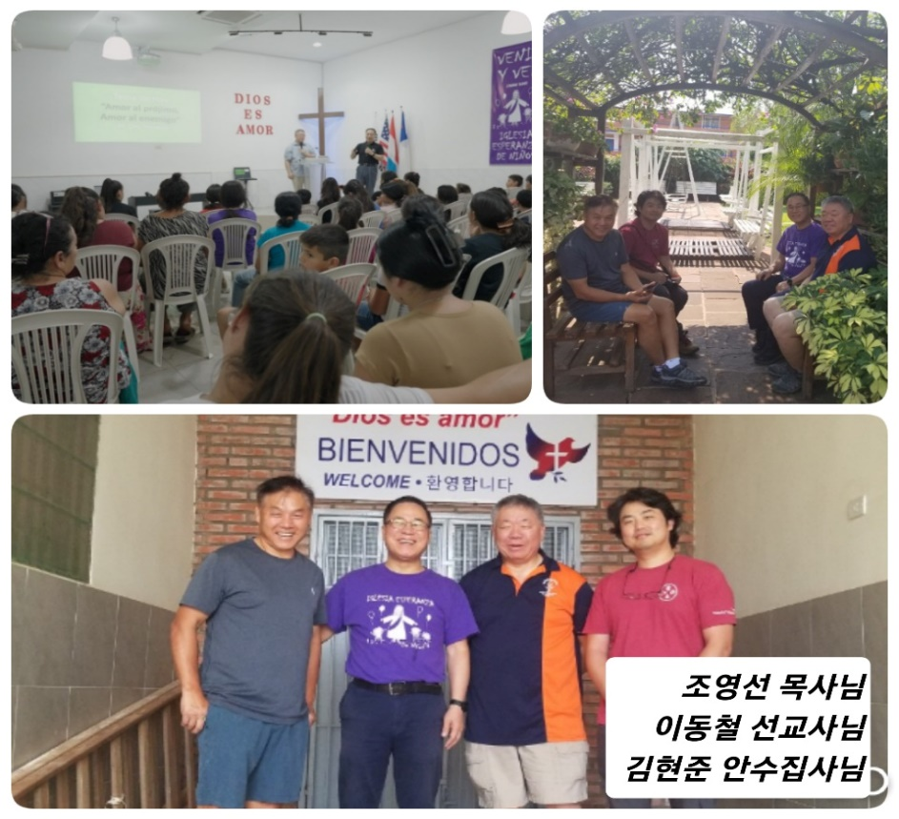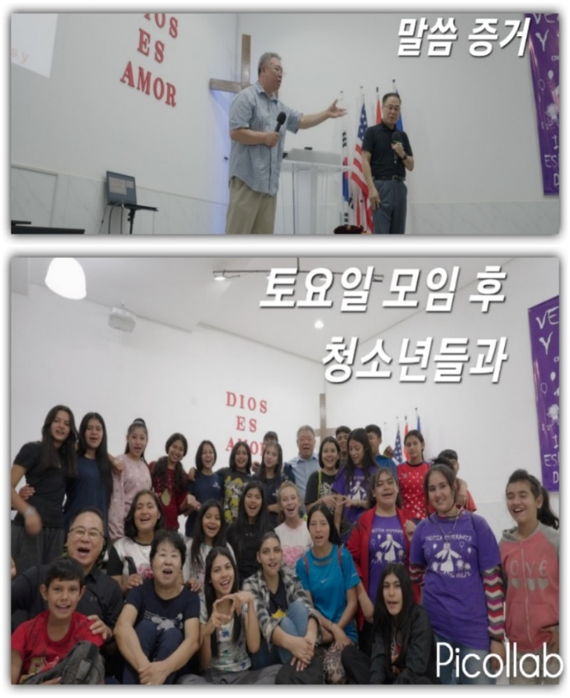

★Learning puppetry in preparation for Christmas,
teaching musical instruments, and starting a Korean school.
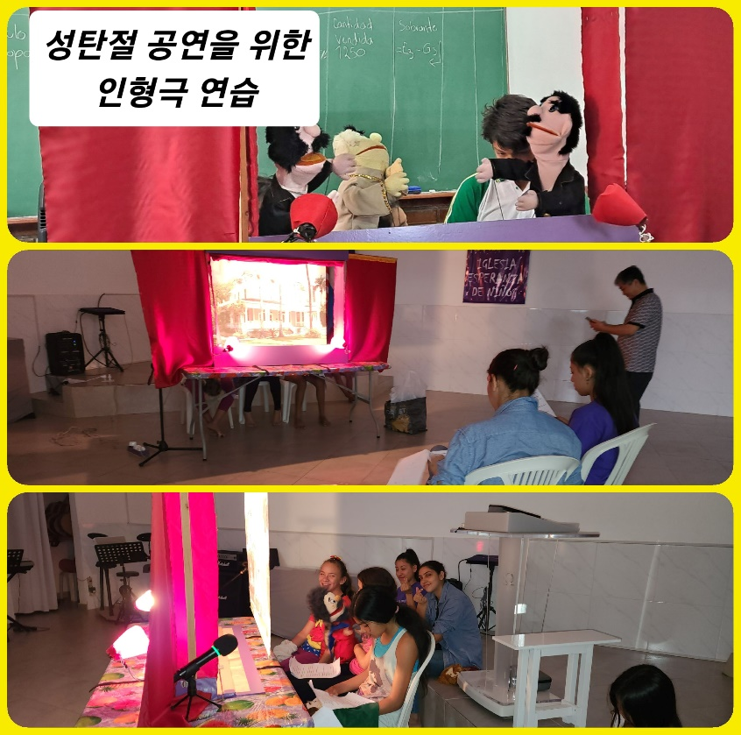
We are learning puppetry to prepare for the <Christmas Celebration Service> in December.
With the help of a missionary, we teach puppetry to children, and as we watch them having fun, we discover various talents.
We continue to teach guitar and piano, and I also continue to teach drums. In particular, the Korean language school, which has been closed for a while, will begin teaching again in early October.
Children now want to learn actively, where they used to learn passively.
The Korean Wave has begun to blow in Paraguay, albeit late. Hallelujah!

The <3rd Five-Year Plan>, which started in September, will be a very important period for missions in Paraguay.
Since this is a time when teenagers are changing into young adults, there are so many things to support, so we need the strong work of the Holy Spirit and the prayers and love of JSBMF. Thank you for your unwavering love and cooperation.

In the testimony to Moses, “He counted the humiliation suffered for Christ’s sake as greater wealth than all the treasures of Egypt, because she was looking forward to a reward. So she departed for Egypt in faith, not fearing the king’s wrath, but as seeing Him who is invisible. “(Hebrews 11:26,27)
I dare to try to imitate Moses. I hope to complete the path I can run only by faith, and I hope to remain as a missionary who spreads the gospel while looking to Jesus Christ, who rewards faith.
We hope that JSBMF all members, and families will be filled with the love and grace of the Lord.
Thank you. Shalom!!!

Your Missionaries in Paraguay
Ok Jin & David Nam
★<Prayer Topics for the 3rd Five-Year Plan for Paraguay Mission (September 2023 to August 2028)>
1. For <Hope Academy> and After School – securing church workers and teachers
2. For building education centers, bakeries, and opening kindergartens
3. Evangelization of the entire village of <Bañado Sur>, the slum where the church is located.
4. 350 <Christ's Warriors> Goal
5. May the history of soul salvation be enriched through <Church of Hope>.
6. For the continuation of the fullness of the Spirit.
“Paraguay, Born Again!” My Lord, my God. Please receive us and lead us! Amen.

