**“파라과이여, 다시 태어나라” (Paraguay must be born again) (요3:7)**

**Esperanza del Paraguay (“파라과이의 희망”)**

**Paraguay Mission 3rd Five Year Plan**

**"If a grain of wheat falls to the ground and does not die, there is one thing, and**

**if it dies, it will bear much fruit" (John 12:24)**

**The 5 goals of the 3rd 5-year plan**

**Worshipers, Disciples, Intercessors, Volunteers, Evangelists**

**Dear Officers and Supporters of JSBMF**

Hallelujah!

Greetings to the JSBMF members family in the love of our Lord Jesus Christ

Looking back on 2023, which started with new hearts and hope, I would like to express my gratitude to KCC and the pastor.

I am just thankful because I cannot carry out the missionary work itself without prayers and support in the mission field.

Knowing that you prayed for us during times of weakness became a source of courage, and the support sent by the congregation, through your frugal sacrifices, has become a reliable pillar for the journey ahead. In the words of the Apostle Paul who confessed, "I thank him who has given me strength, Christ Jesus our Lord, because he judged me faithful, appointing me to his service" (1 Timothy 1:12), we strive to be faithful on the path we have walked, and we are grateful for your support and collaboration.

Thank you for holding us up, standing by our side, and partnering with us in the journey of faithfulness, much like Paul's dedication in serving our Lord Jesus Christ.

**★ Christmas Thanksgiving Service**

How did the Lord guide the mission field to the joyous and blessed day of the birth of baby Jesus? How did the church members grow up? What kind of service and service have you performed? Thank you for the opportunity to settle the account. The number of children coming to church because of gifts has decreased, so now there are almost no children coming to church just to get anything. In particular, Sunday school teachers worked hard to serve Sunday school children even though they were not fully mature teenagers. Sunday school is important, but I am proud and proud to see the teachers in charge of Sunday school changing. We gave gifts to children who attended school diligently throughout the year, studied hard at school, and served well. Also, December was the last time we distributed relief goods that had been distributed for a year, and starting next year, we will look at each situation and share with them individually.

**★ 1st Youth Camp**

As soon as the kids got out of school, we rented a swimming pool for a day so they could swim and enjoy themselves all day. And we went to a summer camp for 3 days and 2 nights with youth leaders and 22 children who would become leaders in the future.

The church takes special care to ensure that children who have started their summer vacation do not stop training and learning during the vacation. Children in slums receive little training from their parents from an early age, so they tend to stray easily, so special care must be taken. If you attend the children's and middle school camps in the first week of January, you will continue the Summer Academy. Please continue to pray for the Summer Academy, Camp, VBS, Trip, etc., which will continue until Wednesday, February 14th.

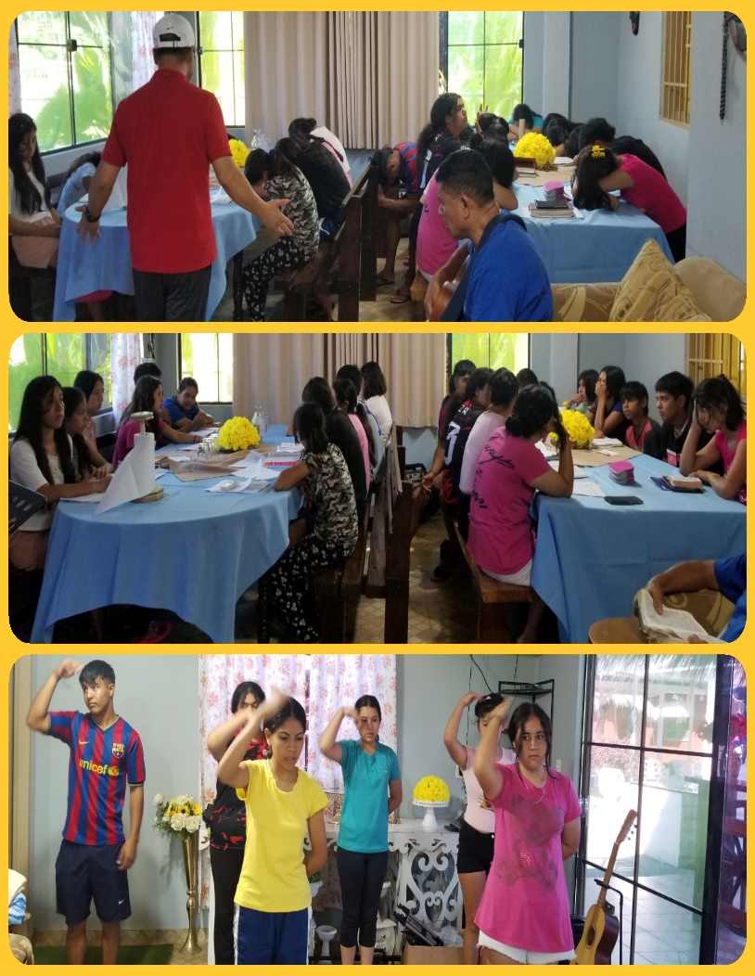

**★ Grace Community Chapel at Sydney Paul Nam (First son) 파라과이 방문**

GCC Sydney Church visited Paraguay. This year, Hinesville Full Gospel Church (Rev. Choi Hyeong-cheol), New Jersey Myungseong Church (Rev. David Seo), El Paso Agape Mission Church (Rev. Ji-woo Lee), 153 Church (Rev. Joo-young Kim), and Rev. Cho Young-sun (Pittsburgh Korean Church) who serves as the chairman of the Overseas Mission Committee of the Korean General Assembly, missionary David Lee (missionary in Honduras), ordained deacon Hyun-jun Kim (Rev. Woong-cheol Kim of Evergreen Church), and finally, Rev. Paul Nam and church members from Sydney visited the mission field in Paraguay and gave us encouragement and courage. This year made me think that God had poured special blessings on Paraguay. Church leaders get excited when the mission team visits. When they visited, the pastors bought us hamburgers from Burger King. I was happy and the children were happy, so it seemed like these things made the children feel attached to the church and feel the love of the Lord. We would like to sincerely thank the members of GCC at Sydney for helping us paint the Sanctuary.

“One person will be able to overcome it, but two people will be able to withstand it. A rope of spade is not easily destroyed” (Ecclesiastes 4:12). We will soon be entering the new year of 2024, and this new year will be a time of preaching to 150 children and focusing on the Word and daily life. Training will be conducted. In the Lord's providence that brought together JSBMF, we will continue to work together in prayer in the new year to expand the gospel. Thank you from the bottom of our hearts for being with us through prayer and love throughout the year.

Your Missionaries in Paraguay

**¡¡ Happy New Year ● Feliz Año Nuevo !!**

Ok Jin & David Nam

★<Prayer Topics for the 3rd Five-Year Plan for Paraguay Mission (September 2023 to August 2028)>

1. For <Hope Academy> and After School – securing church workers and teachers

2. For building education centers, bakeries, and opening kindergartens

3. Evangelization of the entire village of <Bañado Sur>, the slum where the church is located.

4. 350 <Christ's Warriors> Goal

5. May the history of soul salvation be enriched through <Church of Hope>.

6. For the continuation of the fullness of the Spirit.

**“Paraguay, Born Again!”**  **My Lord, my God. Please receive us and lead us! Amen.**