**“파라과이여, 다시 태어나라” (Paraguay must be born again) (요3:7)**

**Esperanza del Paraguay (“파라과이의 희망”)**

**Paraguay Mission 3rd Five Year Plan**

**"If a grain of wheat falls to the ground and does not die, there is one thing, and**

**if it dies, it will bear much fruit" (John 12:24)**

**The 7 goals of the 3rd 5-year plan**

**Priesthood, Worshipers, Disciples, Intercessors, Volunteers, Evangelists, Doer**

**Dear Officers and Supporters of JSBMF**

Hallelujah!

Greetings to the JSBMF members family in the love of our Lord Jesus ChristI heard that there was a lot of snow and cold in the United States and Korea this winter.Here in Paraguay, unlike before, we are having a more humid and hot summer.

Looking at the climate that is different from before, the constant news of war, and the world complaining of economic difficulties, <Only Jesus, Only the Bible, Only Faith> helps us live a life that “hopes only in Jesus Christ, the Lord of faith and perfecter of us on this earth.”

**★ Events during summer vacation**

**\* Read the Bible**

In order to achieve the church's goal this year, “Let us strive to know Jehovah” (Hosea 6:3), this summer vacation was spent intensively teaching children to read the Bible. This may be a boring goal for adults, but it is an even more boring goal for children. Nevertheless, like a house on the sand collapsing from wind and rain, we cannot lead the church solely on events, so we are trying to focus more on spiritual matters.

At first, 21 people attended, but as time went by, the number decreased, and only 7 people finished reading the New Testament three times. Although I understood, I felt uneasy because it was not an environment where you could be diligent about studying. I challenged them to practice concentration by sitting in a chair for 50 minutes and experience the joy of knowing the Bible through reading the Bible, but it was not easy. Still, some kids started to get better.

**\* Leader teaches Korean**

After teaching the three leaders the basics of Korean, we had them teach it to other children.

I took on the challenge because teaching means learning. The result is was funny.

As this is the reality of living in a slum, we accept this situation and continue to challenge our children as if we were looking for pearls in the sand.

Here, when children turn 14, their parents make them work to earn money, so training at the church is often not continuous. Still, by knocking and knocking, we are turning even a small number of children into <warriors of Christ>.

**\* Picnic with volunteer leaders**

During the hot summer vacation, I went on a one-day picnic with the children that studied and volunteered with me. The original plan was to go on a trip with the children for 3 days and 2 nights, but despite this, not many children consistently attended, so we took the children who volunteered, had a hearty lunch, and had a fun day.

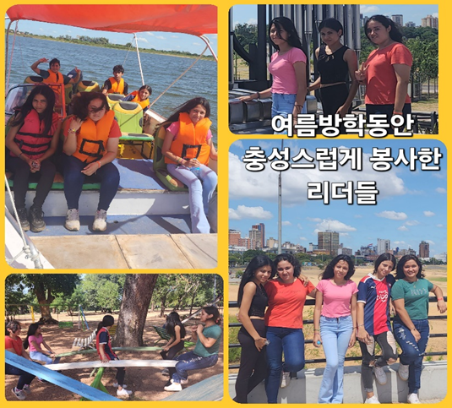

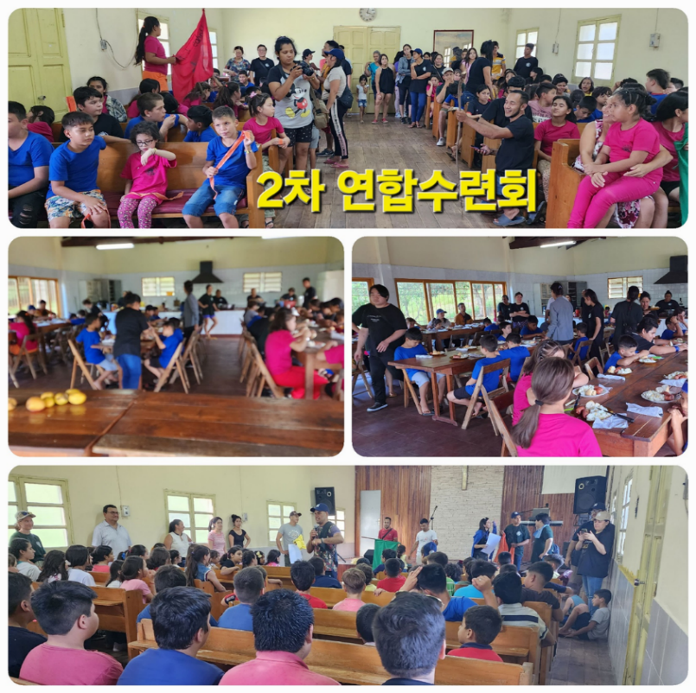

**★ 2nd joint retreat**

The second camp ended with grace thanks to the prayers of the church and believers. Since the first camp was held in December last year and only children from our church attended, we gathered together with other local churches for the second camp. 110 children gathered and ended the camp with great grace.

The teachers were made up of local people, and everything, including praise and group study, was left to the local people to be trained. Although they were inexperienced, they had to take care of the children from now on, so they proceeded by having local people take care of it.

During this summer vacation, we were unable to hold the <Summer Bible School> and <Evangelism Meeting> that we had planned. Last summer, Hinesville Full Gospel Church (Pastor Choi Hyeong-cheol) visited and we attended together, but this time, it was too difficult to handle alone, so we changed our plan to hold a winter Bible school during the winter vacation in July. There was the pain of not being able to carry out the work I had planned, but on the other hand, it was an opportunity to obey God and experience the work of the Holy Spirit. This winter vacation, the Pittsburgh Korean Church (Pastor Cho Young-sun) decided to visit Paraguay and work together.

**★**  **Sharing scholarships and sharing the cost of purchasing school**

**uniforms for volunteers.**



In 2024, we decided to distribute the scholarship to two academic scholarship recipients and five working scholarship recipients after reviewing their religious life and church volunteer activities despite their difficult family circumstances. Additionally, more living expenses are provided to two adults in difficult circumstances. We are so grateful that the church and one individual participated in sharing scholarships and were able to help the children. We are praying for educational support and vocational training as more children will enter college starting next year. Another good news is that one young person entered the seminary this year and began studying.

She (Fabiana) was a 23-year-old sister who decided to dedicate her life to God. She is in charge of Sunday School and is trained by a leadership group that meets every Saturday.

**★ First free dental care in 2024**

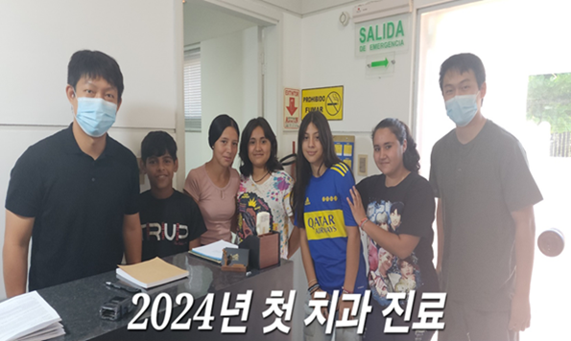

**★ I held my wife's 70th birthday party at the church.**

My wife's 70th birthday celebration was shared with the children at church. It may be one of the joys and sorrows of being a missionary, but it is not possible to celebrate various events with your children or loved ones. A few days ago, a close deacon passed away, and she was very uneasy because she could not attend the funeral. I am so grateful that my wife can handle the missionary role with me.

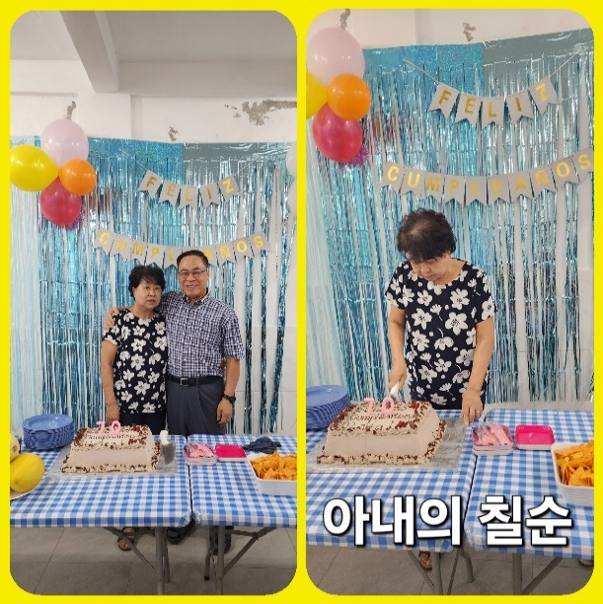 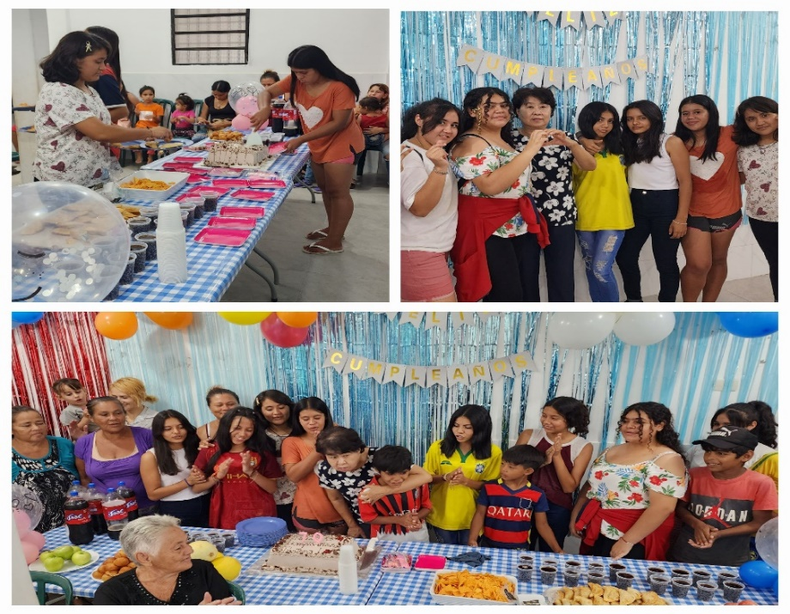

“Teach us to number our days, that we may gain a heart of wisdom” (Psalm 90:12)

Thinking about my wife's 70th birthday and the woman elder who passed away, I take a moment of meditation to wrap my heart around the word of the Lord. There will be a lot of time between life and death, but as we count the hours and days each day, we hope to give more of our remaining time to the Lord.

We are sincerely grateful for the prayers and love of the members of JSBMF who are working together in the Paraguay mission despite the difficult economic news. I pray that the glory of the Lord will fill the JSBMF families. Shalom.

Your Missionaries in Paraguay

Ok Jin & David Nam

★<Prayer Topics for the 3rd Five-Year Plan for Paraguay Mission (September 2023 to August 2028)>

1. For <Hope Academy> and After School – securing church workers and teachers

2. For building education centers, bakeries, and opening kindergartens

3. Evangelization of the entire village of <Bañado Sur>, the slum where the church is located.

4. 350 <Christ's Warriors> Goal

5. May the history of soul salvation be enriched through <Church of Hope>.

6. For the continuation of the fullness of the Spirit.

**“Paraguay, Born Again!”**  **My Lord, my God. Please receive us and lead us! Amen.**