**“파라과이여, 다시 태어나라” (Paraguay must be born again) (요3:7)**

**Esperanza del Paraguay (“파라과이의 희망”)**

**Paraguay Mission 3rd Five Year Plan**

**"If a grain of wheat falls to the ground and does not die, there is one thing, and**

**if it dies, it will bear much fruit" (John 12:24)**

**The 7 goals of the 3rd 5-year plan**

**Priesthood, Worshipers, Disciples, Intercessors, Volunteers, Evangelists, Doer**

**Dear Officers and Supporters of JSBMF**

Hallelujah! Greetings to the JSBMF members family in the love of our Lord Jesus Christ

As winter recedes and we welcome the fragrance of spring, I hope that the glory of the Lord will fill the members of JSBMF and the family.

“As long as the earth continues, planting and harvest, cold and heat, summer and winter, day and night, will not cease” (Genesis 8:22)

God promised, but there are still people suffering from war on one side of the world, and there are many people living in poverty, so I earnestly pray that You, God will help them.

There are times when missionary work is tiring and difficult and I want to sit down, but I think of the saints and pastors who continue to work together with me in prayer and love, and I gain strength, comfort, and courage and run forward.

**★ Baby Dedication Ceremony**

It has been 11 years since we started missionary work in Paraguay, and there are two ministries that we have not yet implemented.

The first is the baby dedication ceremony and the second is the communion ceremony.

Once I start practicing the Holy Communion, I will have to keep doing it, but I am putting it off because I am worried that <The Lord's Supper> will be treated as an event for the children. Since adults are still in an immature stage, it was decided to wait a little longer before holding the Holy Communion service.

However, the baby dedication ceremony was held on this Easter Sunday.

One student, Araceli Aquino (16 years old), requested a special request for her younger sibling.

Araceli lives with her mom and her three younger siblings.

Her father died last year, and the baby she received this time is Araceli's youngest sibling, who was born after the father passed away.

Since her mother is so cruel that she does not take care of her children properly, she helps Araceli around the house by working and going to school in the evenings. She said Araceli had a special request from me, “Pastor, please hold a dedication ceremony for my sister. My mom doesn't go to church, and she doesn't believe in Jesus, but she can have a baby dedication if I become my sister's guardian, right?”

She made a tearful request, saying, “I will take responsibility for my younger sister from now on, so please have a baby dedication.”

Araceli is a student who is good at studying and has leadership skills. She is receiving a scholarship from Bansuk Presbyterian Church in LA, and because she is good at leading children, she serves as a Sunday school teacher.

Our church held a small first birthday party for her baby, and her mother and her family attended and celebrated.

Next year, she will be in her third year of high school. If God permits, she plans to go to college. She hopes to study at the seminary and become a pastor or wife. It is not common for students from slums to want to go to university.

Nevertheless, they are growing into workers dedicated to the future.

My wife (missionary Nam Ok-jin) is currently in Korea due to spinal stenosis. She had her procedure done five years ago, but again due to unbearable pain, she is recovering and ready to return to Paraguay, where Araceli and other leaders have taken on the vacancy of my wife and have done a good job.

This dedication ceremony was a very meaningful ceremony for me. I confess that it is only God’s grace and love.

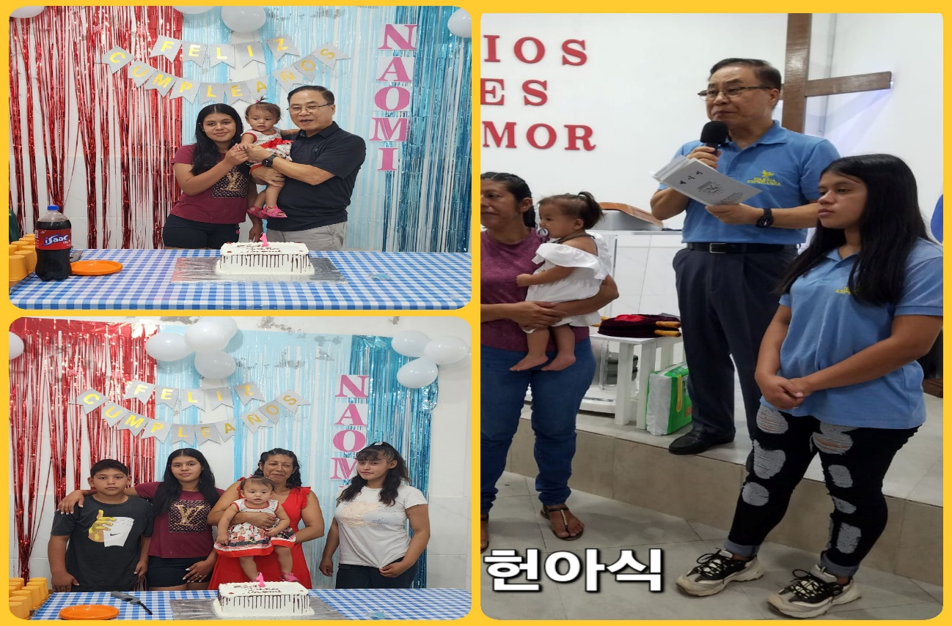

**Araceli 가족**

**★Construction of church members’ houses and restrooms**

We believe this is an essential ministry while carrying out our missionary work in Paraguay, so we are carrying out a ministry of building and repairing houses and bathrooms for church members who are at least a little dedicated. The slums are in poor environments, so any help can improve the children's environment, keep them healthy, and help them study. So far, we have built three houses, completely repaired two houses, and built three toilets.

This time, we built a house (two rooms, a bathroom) at the church member's house and built two bathrooms. If I had the financial means, I would like to build more. It hurts my heart to see them live in such an unsanitary environment, so I am trying to provide more help. We build buildings as a means of spreading the gospel of the Lord, and most of those who benefit are passionate about their religious life, so we are just thankful.

Marta 자매

**★Phila Youngsang Presbyterian Church mission team visited our mission field**

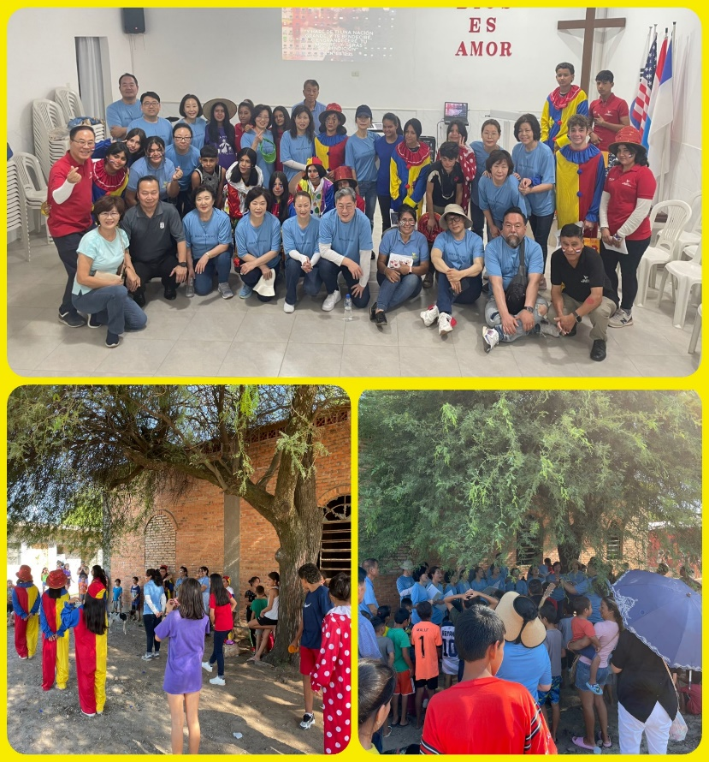 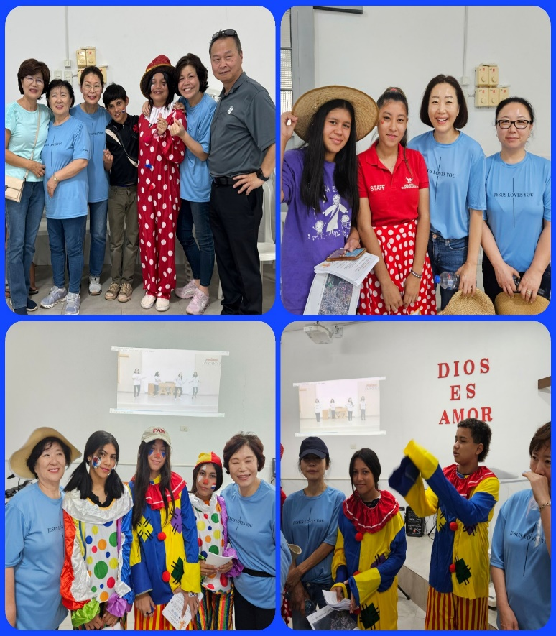

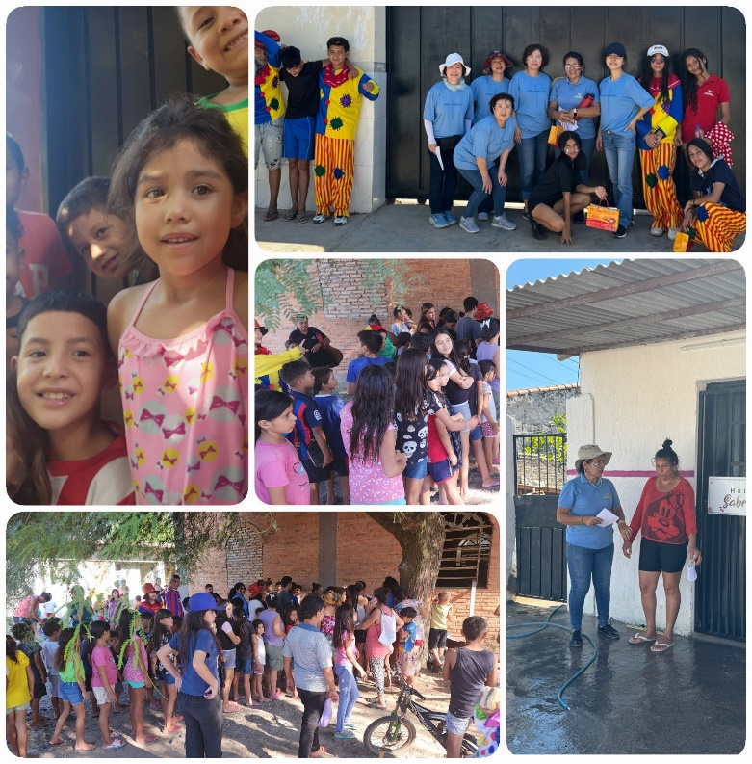

Yeongsang Presbyterian Church, located near Philadelphia, visited our mission field for one day during Passion Week. I felt uneasy because I couldn't hold an evangelism meeting in February, but a missionary who is filled with the Holy Spirit asked me to visit our mission field, so I held a one-day evangelism meeting with a mission team of 17 people. We spent the day evangelizing happily and joyfully with our children, singing praises and bearing witness to the Word at the soccer field. My children really enjoy evangelizing, and when guests come from outside, they sing with excitement, and seeing them praising God despite the heat brings glory to the Lord.

We also had a hamburger party in the evening. Hahaha (In fact, when guests come and visit, we always take the children to Burger King and have a hamburger party. Our children rarely have the opportunity to eat hamburgers at Burger King, so going as guests is the best gift for them.)

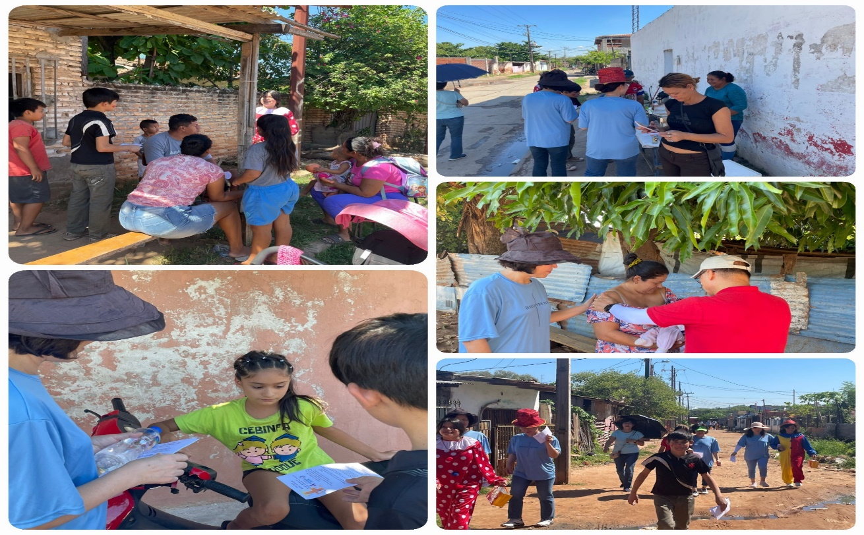

**★ Our praise team visits other mission areas and gives special praise**

Our church's praise team visited other mission sites that were weaker than ours and gave special praise, giving strength and courage and instilling dreams in the children in those areas. I pray that when the youth grow up, they will be able to form an evangelism team and conduct street evangelism rallies. It may be necessary to establish a church in a distant area and call for a pastor, but I think it is more effective to train the children of the church to create God's army and evangelize, so I pray and wait for the children to grow up.

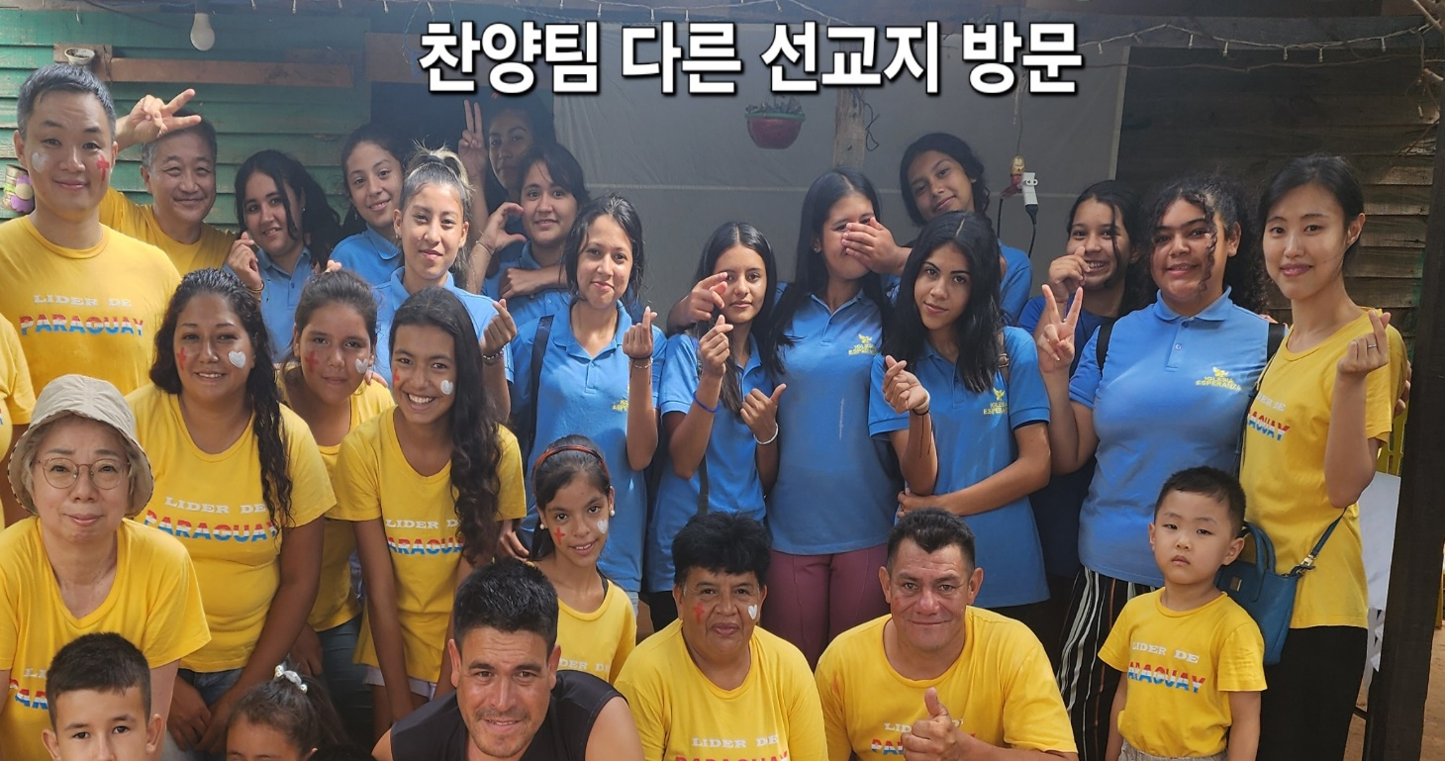

My wife will return to Paraguay on May 7th after surgery. It was difficult because her wife's absence gave her more work to do, but she couldn't delay, so she went to Korea and had her surgery. I came to think that it was God's work for missionaries to take good care of their bodies. Even though the pain was getting worse, I had to postpone the surgery due to circumstances that did not allow for it. However, recovery also takes time, so please pray for me.

As Apostle Paul confessed, “If we live, we live for the Lord, and if we die, we die for the Lord. Therefore, whether we live or die, we are the Lord’s.” (Romans 14:8) Since life and death and happiness are in the hands of the Lord, “what we ask of those in charge of us is faithfulness.” Follow along and run faithfully in your assigned duties.

We are deeply grateful for the love of JSBMF officers and supporters who always work together for the mission in Paraguay. We pray that the glory of our Lord will fill the members of JSBMF and your family. Shalom

Your Missionaries in Paraguay

Ok Jin & David Nam

★<Prayer Topics for the 3rd Five-Year Plan for Paraguay Mission (September 2023 to August 2028)>

1. For <Hope Academy> and After School – securing church workers and teachers

2. For building education centers, bakeries, and opening kindergartens

3. Evangelization of the entire village of <Bañado Sur>, the slum where the church is located.

4. 350 <Christ's Warriors> Goal

5. May the history of soul salvation be enriched through <Church of Hope>.

6. For the continuation of the fullness of the Spirit.

**“Paraguay, Born Again!”**  **My Lord, my God. Please receive us and lead us! Amen.**

**● US Mailing Address (미국 연락처)** :

**All Nations**

**1516 Lakeway Drive** **• Little Elm, TX 75068**

**● Bank of America** (**Pay to the Order : All Nations Church of Dallas)**

**Routing #: 111000025** **Account #: 488028516745**

**● e-mail :** [**davidnam1128@gmail.com**](mailto:davidnam1128@gmail.com)

**● Paraguay Address (파라과이 연락처)**

**Tacuari y entre 38 y 39 proyectada • Asuncion, Paraguay** **+595 994-796900(cell phone)**

**●** **한국**: NAM DAVID HAK(국민은행) 054901-04-203605