**“파라과이여, 다시 태어나라” (Paraguay must be born again) (요3:7)**

**Esperanza del Paraguay (“파라과이의 희망”)**

**Paraguay Mission 3rd Five Year Plan**

**"If a grain of wheat falls to the ground and does not die, there is one thing, and**

**if it dies, it will bear much fruit" (John 12:24)**

**The 7 goals of the 3rd 5-year plan**

**Priesthood, Worshipers, Disciples, Intercessors, Volunteers, Evangelists, Doer**

**Dear Officers and Supporters of JSBMF**

Hallelujah! Greetings to the JSBMF members family in the love of our Lord Jesus Christ

I remember suddenly having this thought while communicated with an elderly pastor shortly after I began my ministry. <How did he serve as a pastor until that age?> <Can I serve as a pastor for as many years as that person?>

During my short ministry, I experienced conflicts and frustrations with people, experienced things that I could not handle, and thought about the limitations of human beings... Now that I am turning into something like that old pastor, I ask myself, “How did I get to this point?” I realized that this sentence, **“God is with me,”** is the answer.

In Psalm 23, written by David in his old age, “Even though I walk through the valley of the shadow of death, I will fear no evil.

“For the Lord is with me.”

Even now, missionary work is still not easy, there are times when it seems like a heavy burden, living with locals who do not change and obey, and even after a long time, when I encounter people who are quick to pursue their own interests and fall behind in serving others, I raise my hands and say, I have no choice but to shout out, “The Lord who promised**, “He is with me!”**

**★ Hiking training with leaders**

On a public holiday here, I took the leaders to a small mountain to train their bodies and minds.

For the children who wake up late on holidays and become lazy because they have nothing to do, I took them out because it was my job to train them to walk with me.

After going for a hike with the leaders (the current leaders are all female students), due to resistance from the boys, I went to the same place the very next week with the boys who were to be raised as leaders. It is good to have men as leaders, but the situation in Paraguay is such that boys do not like to receive training, and when they become teenagers, they are forced to earn money at home, so religious training is not easy. In Paraguay, due to historical reasons, there is a tendency to look down on women as if being born as a man was a great prestige (like Korea in the past), which is also a factor that makes it difficult to lead men.

Nevertheless, I am working hard to lead the boys.

**★ Mother's day event**

On Mother's Day here, we prepared food for mothers, prepared a special delivery, and held a service. After the service, we also had time to prepare and share the household needs and groceries that we had saved up.

The amount of hard work mothers put in is several times greater than that of men. Moreover, I think that the hardships of women who keep their families without husbands are years of harsh tears.

**★ Please pray.**

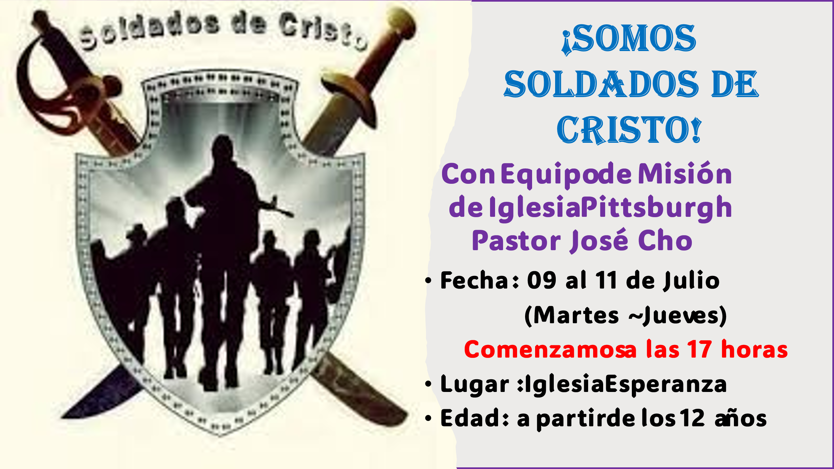

**<청소년수련회: Retreat> <겨울성경학교: VBS>**

**7월9일(화)~11일(목) 7월12일(금) ~ 14일(주일)**

**전 도 집 회**: **7월15일(월) ~ 17일(수) 각 지역 동네 축구장**

The plan for this winter vacation plan is that a team of 12 members from the Pittsburgh Korean Church (Pastor Cho Young-sun) will join us and lead together. This is the first time in 11 years since I started missionary work that I feel very burdened by planning a youth retreat, a winter Bible school, and an evangelistic meeting held outside for two weeks in a row during the winter vacation here. However, with the visit of Pastor Cho Young-sun, the head of the mission committee of the Korean General Assembly, and with the missionary team, I feel more encouraged and ready to carry out the project. Since we cannot save souls without the help and work of the Holy Spirit, please pray **<so that we can bear fruit for the soul rather than just an event>.**

2 Timothy 2:3 “Suffer with me, as a good soldier of Christ Jesus.”

Our goal is to change our children and make them **<Soldado de Cristo>.**

I hope that they will be transformed by the words of Jesus Christ and become loyal workers for their family, society, and country.

I pray that the glory and grace of the Lord will fill the members of JSBMF and your family. Shalom

Your Missionaries in Paraguay

Ok Jin & David Nam

★<Prayer Topics for the 3rd Five-Year Plan for Paraguay Mission (September 2023 to August 2028)>

1. For <Hope Academy> and After School – securing church workers and teachers

2. For building education centers, bakeries, and opening kindergartens

3. Evangelization of the entire village of <Bañado Sur>, the slum where the church is located.

4. 350 <Christ's Warriors> Goal

5. May the history of soul salvation be enriched through <Church of Hope>.

6. For the continuation of the fullness of the Spirit.

**“Paraguay, Born Again!”**  **My Lord, my God. Please receive us and lead us! Amen.**

**● US Mailing Address (미국 연락처)** :

**All Nations**

**1516 Lakeway Drive** **• Little Elm, TX 75068**

**● Bank of America** (**Pay to the Order : All Nations Church of Dallas)**

**Routing #: 111000025** **Account #: 488028516745**

**● e-mail :** [**davidnam1128@gmail.com**](mailto:davidnam1128@gmail.com)

**● Paraguay Address (파라과이 연락처)**

**Tacuari y entre 38 y 39 proyectada • Asuncion, Paraguay** **+595 994-796900(cell phone)**

**●** **한국**: NAM DAVID HAK(국민은행) 054901-04-203605