“파라과이여, 다시 태어나라” (Paraguay must be born again) (요3:7)
Esperanza del Paraguay (“파라과이의 희망”)

Paraguay Mission 3rd Five Year Plan
"If a grain of wheat falls to the ground and does not die, there is one thing, and
if it dies, it will bear much fruit" (John 12:24)
The 7 goals of the 3rd 5-year plan
Priesthood, Worshipers, Disciples, Intercessors, Volunteers, Evangelists, Doer

Dear Officers and Supporters of JSBMF

Hallelujah! Greetings to the JSBMF members family in the love of our Lord Jesus Christ
While the US and Korea are going through a hot summer, here, they are spending the winter and focusing on their mission.
I learned that missionary work is the same principle when I heard the news of the Korean team that achieved great results with a small number of participants at the 33rd Paris Olympics that ended recently. In particular, the women’s national archery team won gold medals 10 times in a row from the 1988 Seoul Olympics to the 2024 Paris Olympics. Of course, the passion and effort of the players should be praised, but the heart and will of Hyundai Motor Group Chairman Chung Eui-sun, who devotedly supported the players behind the scenes, was truly beautiful. I was touched by the way he let the athletes receive applause and rejoiced with them rather than taking the lead.
I am grateful once again to JSBMF members family for partnering with us, as I feel that missions require the passion and hard work of missionaries, but it is the same principle of cooperation that is possible with prayer and loving support from behind the scenes. “Though one can be overpowered, two can withstand it. A three-fold cord is not easily broken” (Ecclesiastes 4:12)
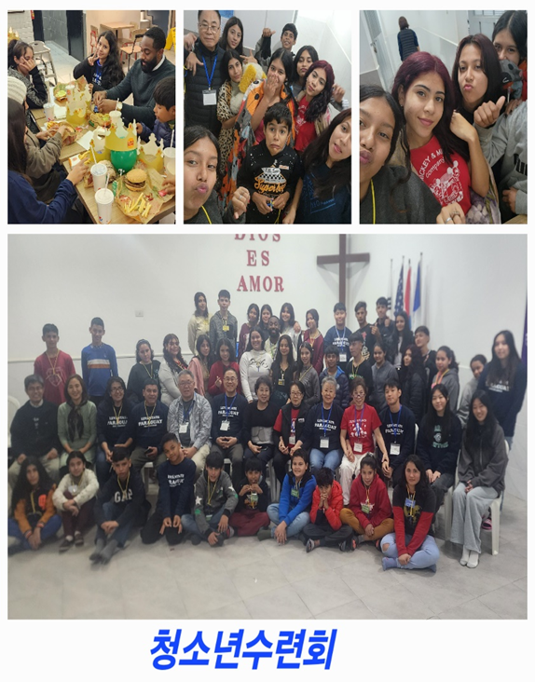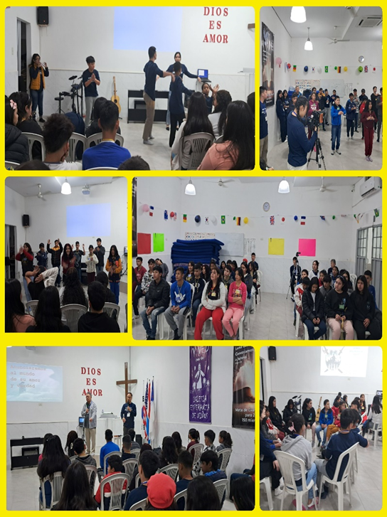

In the winter program that started right at the beginning of the winter break in July, Pastor Young Sun Cho and 10 members of Pittsburgh Korean Church visited Paraguay for nine days, conducting a three-day youth retreat, a three-day winter Bible school, and three days of outdoor evangelism. It was difficult because it was the first time to conduct three types of ministries in a row, but with the dedication of the visiting mission team and the loyalty of the church leaders, we had the opportunity to share the gospel of Christ with the youth, children, and the community. We asked for prayer for this work, and we believe that the Lord's grace will bring much fruit.
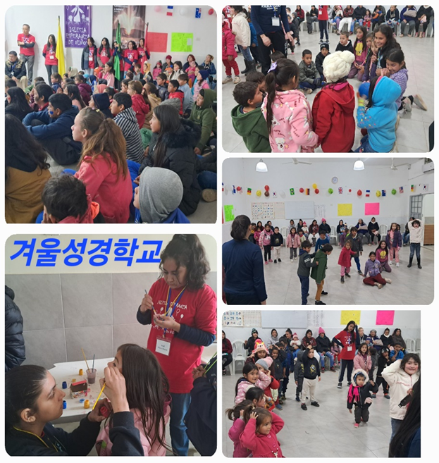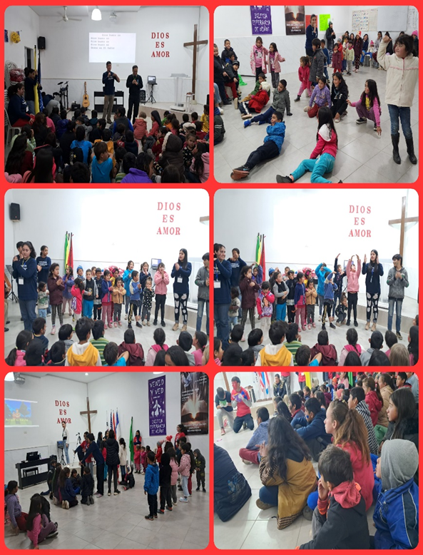
★Evangelistic Crusade

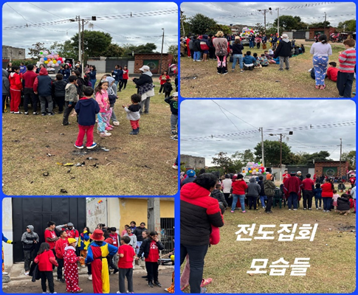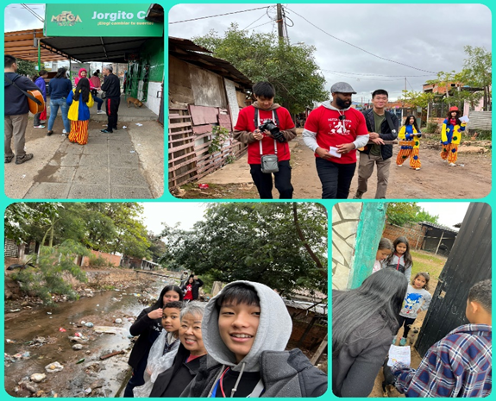
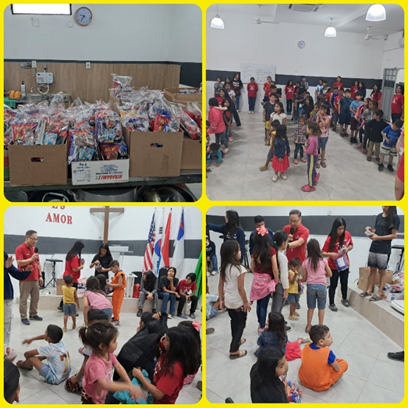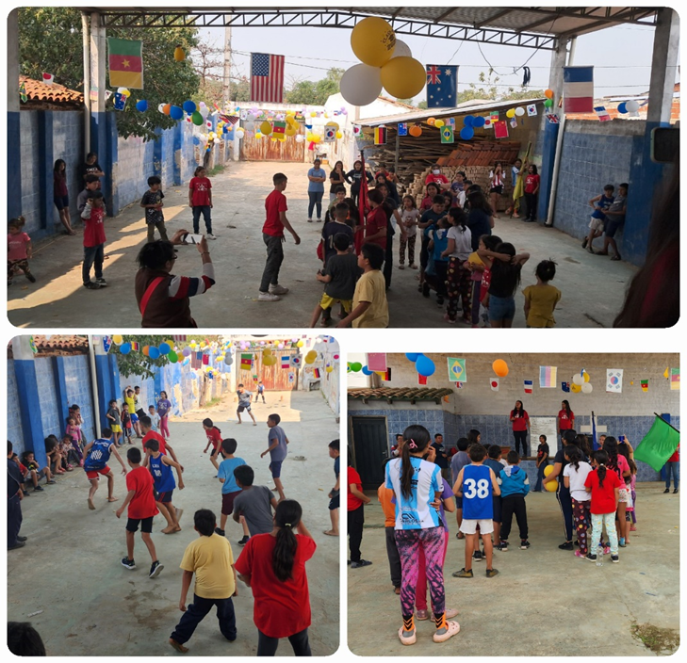
★ Children’s Day
Children's Day in Paraguay has a sad history.
In 1864, Paraguay was at war with Brazil, Argentina, and Uruguay. At the time, Paraguay was stronger than the other South American countries, so it started the Three Kingdoms War to become more powerful. Paraguay's president, Francisco Solano López, mobilized the country and enlisted all men in the army to fight the war, but the adult men were wiped out in the battles in Brazil and Argentina, leaving the majority of the population to be children, women, and the elderly.
However, the president, Francisco Solano López, was a mad warmonger and enlisted children and women in the army.
In 1869, a battle between Brazilian cavalry and Paraguayan troops took place on the plains of Acosta Ñu. The Paraguayan troops were mostly children between the ages of 9 and 15, and the rest were elderly. Paraguay's 3500 boy soldiers fought as a unit, but were defeated by 20,000 Brazilian soldiers. The children fought for more than six hours against Brazilian mounted soldiers with sticks made to look like guns and fake beards to trick the enemy into thinking they were armed soldiers. The Brazilians killed any children who fled or surrendered. More than 3,500 Paraguayan children were killed that day. As if that wasn't enough, when the families of the boys tried to collect their bodies, the Brazilians set fire to the forest and burned them to death.
Paraguay had a sad history, but now it is making a glorious history. Now, many churches are spreading the <Gospel of Hope> to children and making them bright, healthy, and warriors of Christ. Hallelujah!

★ Second Leaders
Two weeks ago, we gathered 12 children and started training them as second leaders. In fact, some of them can't even read Spanish. They are mischievous children. But these children have already started to change. I don’t think it’s a change, but rather a recovery of self-esteem. They say that their minds have changed because they think about becoming leaders in the church even though no one brings it up.
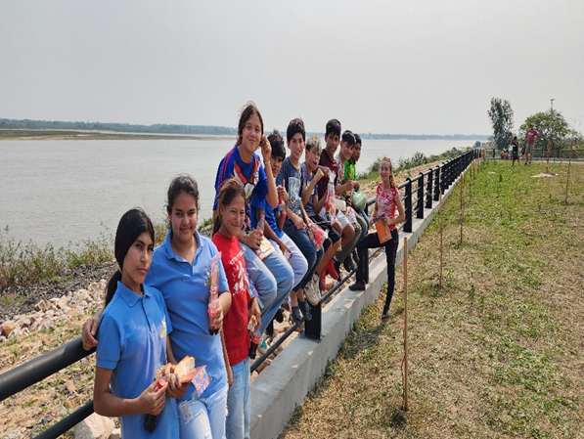
With the heart of God who called Gideon a “great warrior” (Judges 6:12) from the beginning, we are trying to raise other children to be leaders. Children who did not pray began to open their mouths little by little, and children who did not clean but just watched began to pick up the brooms on their own. Please pray that these children will truly become “warriors of Christ.”
★Please pray for us
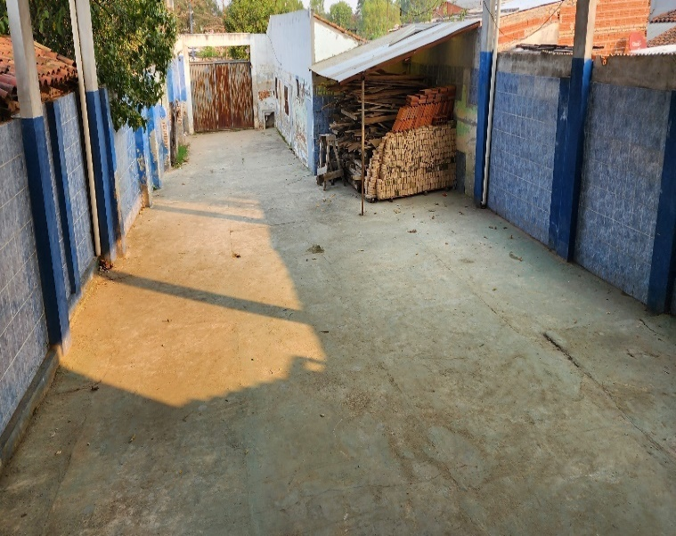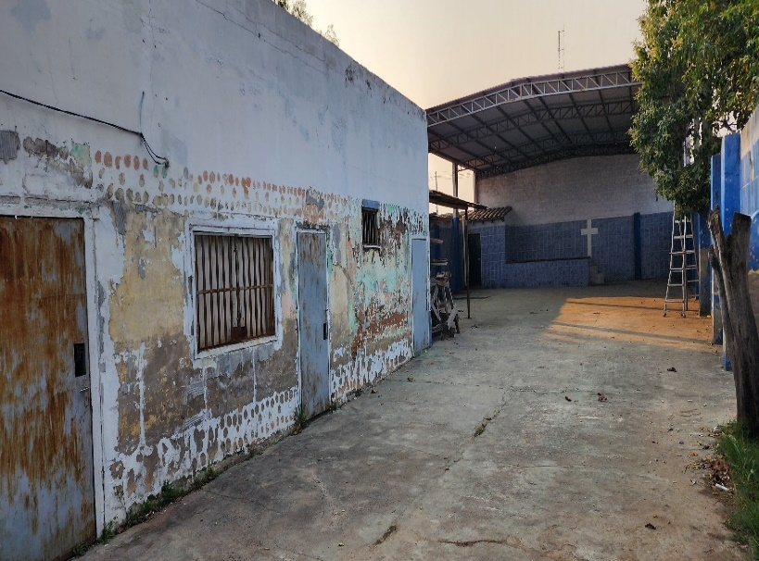
Place of the dormitory for student
The young children will begin graduating from high school this year. We have a plan to make the young children grow into young adults and become <Christian warriors> who serve God and are faithful with all their hearts. We are like a <DORMITORY FOR STUDENT> where we share our lives with the children and live together. I don't think running a<DORMITORY> is easy. However, I believe that this is the only way to help the children advance in life and faith. The calling God gave me was orphan ministry, and I came to Paraguay to fulfill that calling, but the Paraguayan orphanage laws have changed to make it impossible to do without a lot of money. The Holy Spirit, knowing that I could not pursue an orphanage, changed the direction to the slums 11 years ago and guided me to do my ministry there. Now, although it is not orphan ministry, I think that a similar type of ministry is a Boarding School, so I am planning to build it. I want to run a <Vocational training school> and a <Daycare Center> along with the Dormitory and share hope with the children of the slums. Construction is scheduled to begin in May of next year. I plan to go to the United States to build the Dormitory for student and visit churches. I will arrive in the US on September 9th and return on November 19th. Please pray for me to be led by the Holy Spirit.
Jesus taught the crowds to fulfill the will of God the Father who sent him to this earth. “For I have come down from heaven, not to do my own will, but to do the will of him who sent me. And this is the will of him who sent me, that of all those he has given me I should lose nothing, but raise it up at the last day.” (John 6:38-39)
I sincerely thank the JSBMF family for being with us so far. You have prayed for us and supported us, giving us hope for the children. It has given us strength and courage, and we believe it is hope and joy for the children of Paraguay. Thank you.
I pray that you stay healthy in the hot summer and that the glory of the Lord fills the JSBMF members family. Shalom.
Your Missionaries in Paraguay
Ok Jin & David Nam

★<Prayer Topics for the 3rd Five-Year Plan for Paraguay Mission (September 2023 to August 2028)>
1. For <Hope Academy> and After School – securing church workers and teachers
2. For building education centers, bakeries, and opening Daycare Center
3. Evangelization of the entire village of <Bañado Sur>, the slum where the church is located.
4. 350 <Christ's Warriors> Goal
5. May the history of soul salvation be enriched through <Church of Hope>.
6. For the continuation of the fullness of the Spirit.
“Paraguay, Born Again!” My Lord, my God. Please receive us and lead us! Amen.

