**Prayer Letter of January & February 2025**

**1191/150 The Parkland- Bangna, Bangna Trad Rd, Bangna, Bangkok, Thailand 10260** [**woody.kim@om.org**](mailto:woody.kim@om.org)

Dear Prayer Partners,

**30 Years of Thai Mission:** On April 10, we will mark 30 years since beginning the mission in Thailand. We thank God for His faithfulness in guiding and accompanying us and to all those who have supported us through prayers and support. These 30 years have been a journey of witnessing God's preparation and His power to accomplish what humans cannot.

**OM Korea Board Meeting (March 11, Sarang Church, Seoul):** As Sarang Church hosts the WEA World Evangelical Alliance General Assembly at the end of October, the OM East Asia Leaders Meeting is also planned for early November in Seoul. It has been a time to share much in preparation for these events. The Korean churches are leading global missions in partnership with world churches. **Please pray that these two significant gatherings will be well-prepared**.

**OM International Leader Meeting (ILM), March 21-26, Kuala Lumpur, Malaysia:** After serving for 12 years as OM International President, Lawrence Tong passed the leadership to Ian Pickard (UK). A grand event was held with 480 participants, including donors supporting OM ministry, where worship, intercessory prayers, and workshops were held to set the vision and direction for global missions. For Woody, it was a blessing to meet many fundraisers and receive commitments for support. **Please pray for the successful provision of funds allocated to OM East Asia in 2025.**

**Visit of Dell, Husband Nick, and Son Israel to Thailand:** Dell, our spiritual daughter, first met Jesus through our university club ministry and later joined OM Thailand staff in 2006. She married a British brother and has been living in the UK. Dell, Nick, and their son Israel visited Thailand at the end of February. The day after their arrival, Nick suffered a brain hemorrhage due to a fall at the swimming pool. By God's grace, he did not require surgery and is currently recovering with physical therapy. However, as he lacked insurance, the hospital expenses became burdensome. Thankfully, OM and many others provided help. **Please pray for Nick’s swift recovery and safe return to the UK.**

**Earthquake in Thailand and Myanmar:** For the first time in 80 years, Myanmar experienced a significant earthquake. Aftershocks were felt in Bangkok, causing a two-minute tremor that led everyone to evacuate in panic. We also stayed out of our apartment for two days before returning. Thankfully, Bangkok is safe. However, in the Mandalay region of Myanmar, a 7.7 magnitude earthquake caused road closures and disruption in electricity and water supply, leaving people living in tents and on streets. Woody is leading the Myanmar Earthquake Crisis Response fundraising initiative in collaboration with various OM nations.

Currently, there are 13 Vibrant Community Planter (VCP) teams of OM local churches in the Mandalay region. They are distributing food (monthly supplies of rice and water) and survival kits (mosquito nets, blankets, and mats) to 6,000 people.

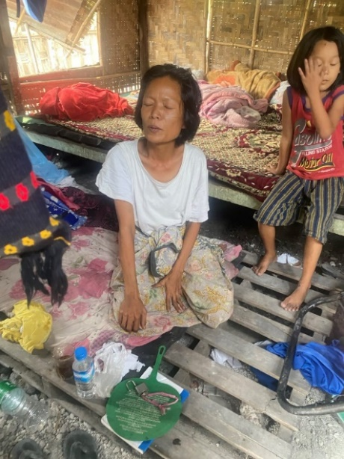We pray that God will use His power to save the churches and believers in Myanmar, provide salvation for the lost, and supply the necessary finances.

OM Myanmar Field Leader Sian Hang visited the affected areas with OM workers to distribute food and water and convey hope and love. During his visit, he met Aye Min Soe, a devout Christian and single mother with brain damage, who had to leave the hospital due to the overwhelming number of emergency cases post-earthquake. She cares for her two young daughters with firm faith that God will heal her. The situation in Mandalay remains chaotic, and many struggle between despair and faith. Please pray for Mandalay. If you want to support the project, please contribute through OM USA- EA Crisis Emergency relief.

Thank you for your prayers and support throughout the 30 years of the partnership. Blessings,

**Woody and Esther Kim**

Financial Support: online giving- Click here - <https://give.omusa.org/om/donate?sc=&fund-id=8000>

To: OM, Memo: Woody & Esther Kim, Operation Mobilization, P.O. Box 444 Tyrone, GA 30290 1-770-631-0432